ADENICSY(Apelo Dental Clinic Management System)

Project Documentation Submitted to the Faculty of the

School of Computing and Information Technologies

Asia Pacific College

In Partial Fulfillment of the Requirements for

Introduction to Systems and Design for CS

SNTSDEV

By

|  |  |
| --- | --- |
| Earl Eufimeah Dahinao | Alfonzo Louise De Vera |
| Patricia Anne Meltran | Janssen Pedrola |
| Guiler Marion Regalado |  |

Table of Contents

List of Figures iv

List of Tables vi

I. Introduction 1

1.1 Project Context 1

1.2 Statement of the Problem 2

1.3 Objectives 2

1.4 Significance of the Project 2

1.5 Scope and Limitations 3

II. Review of Related Literature / Systems 4

2.1 Context of Dental Clinics’ System in The Philippines 4

2.2 Similar Dental Clinic System 4

2.3 Management of Patient Information in Dental Clinic System 4

2.4 Appointment Feature 5

2.5 Interactive Teeth Model 5

2.6 Synthesis 6

III. Current System 7

3.1 Technical Background 7

3.2 List of Processes 7

3.3 SWOT Analysis 8

3.4 Fishbone Diagram Analysis 9

IV. Proposed Solution 10

4.1 Technical Background 10

4.2 Feasibility 10

4.2.1 Operational Feasibility 10

4.2.2 Economic Feasibility 11

4.2.3 Technical Feasibility 11

4.3 Requirements Analysis 11

4.3.1 Product Vision 11

4.3.2 User Classes and Characteristics 12

4.3.3 Product Backlog 13

4.3.4 Prototype 15

4.3.5 Product Roadmap 31

4.3.6 Release Plan 31

V. Conclusion 33

VI. References 35

VII. Appendices 36

Appendix A: Roles and Responsibilities 36

Appendix B: Minutes of the Meetings 37

Appendix C: Other Reference Pictures 45

Appendix D: Methodology 49

# List of Figures

[Fig. 1 Apelo Dental Clinic's file system for patient information 7](https://asiapacificcollege-my.sharepoint.com/personal/jtpedrola_student_apc_edu_ph/Documents/Documents/2ndYearSubjects/2ndYear3rdTermSubjects/SNTSDEV/ProgmatiksFinalPaper.docx#_Toc105242793)

[Fig. 2 SWOT Analysis of Apelo Dental Clinic 8](https://asiapacificcollege-my.sharepoint.com/personal/jtpedrola_student_apc_edu_ph/Documents/Documents/2ndYearSubjects/2ndYear3rdTermSubjects/SNTSDEV/ProgmatiksFinalPaper.docx#_Toc105242794)

[Fig. 3 Fishbone Diagram of Apelo Dental Clinic 9](https://asiapacificcollege-my.sharepoint.com/personal/jtpedrola_student_apc_edu_ph/Documents/Documents/2ndYearSubjects/2ndYear3rdTermSubjects/SNTSDEV/ProgmatiksFinalPaper.docx#_Toc105242795)

[Fig. 4 Product Vision for Patient Users 11](https://asiapacificcollege-my.sharepoint.com/personal/jtpedrola_student_apc_edu_ph/Documents/Documents/2ndYearSubjects/2ndYear3rdTermSubjects/SNTSDEV/ProgmatiksFinalPaper.docx#_Toc105242796)

[Fig. 5 Product Vision for Doctor Users 11](https://asiapacificcollege-my.sharepoint.com/personal/jtpedrola_student_apc_edu_ph/Documents/Documents/2ndYearSubjects/2ndYear3rdTermSubjects/SNTSDEV/ProgmatiksFinalPaper.docx#_Toc105242797)

[Fig. 6 Product Vision for Front-desk Staff User 12](https://asiapacificcollege-my.sharepoint.com/personal/jtpedrola_student_apc_edu_ph/Documents/Documents/2ndYearSubjects/2ndYear3rdTermSubjects/SNTSDEV/ProgmatiksFinalPaper.docx#_Toc105242798)

[Fig. 7 Product Vision for Accounting Staff User 12](https://asiapacificcollege-my.sharepoint.com/personal/jtpedrola_student_apc_edu_ph/Documents/Documents/2ndYearSubjects/2ndYear3rdTermSubjects/SNTSDEV/ProgmatiksFinalPaper.docx#_Toc105242799)

[Fig. 8 ADENICSY Homepage from the Perspective of a Web Visitor 15](https://asiapacificcollege-my.sharepoint.com/personal/jtpedrola_student_apc_edu_ph/Documents/Documents/2ndYearSubjects/2ndYear3rdTermSubjects/SNTSDEV/ProgmatiksFinalPaper.docx#_Toc105242800)

[Fig. 9 ADENICSY About Page 15](https://asiapacificcollege-my.sharepoint.com/personal/jtpedrola_student_apc_edu_ph/Documents/Documents/2ndYearSubjects/2ndYear3rdTermSubjects/SNTSDEV/ProgmatiksFinalPaper.docx#_Toc105242801)

[Fig. 10 ADENICSY Services Page 16](https://asiapacificcollege-my.sharepoint.com/personal/jtpedrola_student_apc_edu_ph/Documents/Documents/2ndYearSubjects/2ndYear3rdTermSubjects/SNTSDEV/ProgmatiksFinalPaper.docx#_Toc105242802)

[Fig. 11 ADENICSY Doctor's Information Page 16](https://asiapacificcollege-my.sharepoint.com/personal/jtpedrola_student_apc_edu_ph/Documents/Documents/2ndYearSubjects/2ndYear3rdTermSubjects/SNTSDEV/ProgmatiksFinalPaper.docx#_Toc105242803)

[Fig. 12 ADENICSY Facilities Page 17](https://asiapacificcollege-my.sharepoint.com/personal/jtpedrola_student_apc_edu_ph/Documents/Documents/2ndYearSubjects/2ndYear3rdTermSubjects/SNTSDEV/ProgmatiksFinalPaper.docx#_Toc105242804)

[Fig. 13 ADENICSY Contact Information Page 17](https://asiapacificcollege-my.sharepoint.com/personal/jtpedrola_student_apc_edu_ph/Documents/Documents/2ndYearSubjects/2ndYear3rdTermSubjects/SNTSDEV/ProgmatiksFinalPaper.docx#_Toc105242805)

[Fig. 14 ADENICSY Initial Page from Sign in Button 18](https://asiapacificcollege-my.sharepoint.com/personal/jtpedrola_student_apc_edu_ph/Documents/Documents/2ndYearSubjects/2ndYear3rdTermSubjects/SNTSDEV/ProgmatiksFinalPaper.docx#_Toc105242806)

[Fig. 15 ADENICSY Login/ Register Page 18](https://asiapacificcollege-my.sharepoint.com/personal/jtpedrola_student_apc_edu_ph/Documents/Documents/2ndYearSubjects/2ndYear3rdTermSubjects/SNTSDEV/ProgmatiksFinalPaper.docx#_Toc105242807)

[Fig. 16 ADENICSY Register Page 19](https://asiapacificcollege-my.sharepoint.com/personal/jtpedrola_student_apc_edu_ph/Documents/Documents/2ndYearSubjects/2ndYear3rdTermSubjects/SNTSDEV/ProgmatiksFinalPaper.docx#_Toc105242808)

[Fig. 17 ADENICSY Login Page 19](https://asiapacificcollege-my.sharepoint.com/personal/jtpedrola_student_apc_edu_ph/Documents/Documents/2ndYearSubjects/2ndYear3rdTermSubjects/SNTSDEV/ProgmatiksFinalPaper.docx#_Toc105242809)

[Fig. 18 ADENICSY Home Page Once Patient Logged In 20](https://asiapacificcollege-my.sharepoint.com/personal/jtpedrola_student_apc_edu_ph/Documents/Documents/2ndYearSubjects/2ndYear3rdTermSubjects/SNTSDEV/ProgmatiksFinalPaper.docx#_Toc105242810)

[Fig. 19 Home Page When Menu Bar is Clicked 20](https://asiapacificcollege-my.sharepoint.com/personal/jtpedrola_student_apc_edu_ph/Documents/Documents/2ndYearSubjects/2ndYear3rdTermSubjects/SNTSDEV/ProgmatiksFinalPaper.docx#_Toc105242811)

[Fig. 20 Account Settings Page 21](https://asiapacificcollege-my.sharepoint.com/personal/jtpedrola_student_apc_edu_ph/Documents/Documents/2ndYearSubjects/2ndYear3rdTermSubjects/SNTSDEV/ProgmatiksFinalPaper.docx#_Toc105242812)

[Fig. 21 Information Request Page 21](https://asiapacificcollege-my.sharepoint.com/personal/jtpedrola_student_apc_edu_ph/Documents/Documents/2ndYearSubjects/2ndYear3rdTermSubjects/SNTSDEV/ProgmatiksFinalPaper.docx#_Toc105242813)

[Fig. 22 Appointment Page 22](https://asiapacificcollege-my.sharepoint.com/personal/jtpedrola_student_apc_edu_ph/Documents/Documents/2ndYearSubjects/2ndYear3rdTermSubjects/SNTSDEV/ProgmatiksFinalPaper.docx#_Toc105242814)

[Fig. 23 Appointment Terms and Condition 22](https://asiapacificcollege-my.sharepoint.com/personal/jtpedrola_student_apc_edu_ph/Documents/Documents/2ndYearSubjects/2ndYear3rdTermSubjects/SNTSDEV/ProgmatiksFinalPaper.docx#_Toc105242815)

[Fig. 24 Appointment Dates 23](https://asiapacificcollege-my.sharepoint.com/personal/jtpedrola_student_apc_edu_ph/Documents/Documents/2ndYearSubjects/2ndYear3rdTermSubjects/SNTSDEV/ProgmatiksFinalPaper.docx#_Toc105242816)

[Fig. 25 Available Doctors on a Certain Day 23](https://asiapacificcollege-my.sharepoint.com/personal/jtpedrola_student_apc_edu_ph/Documents/Documents/2ndYearSubjects/2ndYear3rdTermSubjects/SNTSDEV/ProgmatiksFinalPaper.docx#_Toc105242817)

[Fig. 26 Choosing Service 24](https://asiapacificcollege-my.sharepoint.com/personal/jtpedrola_student_apc_edu_ph/Documents/Documents/2ndYearSubjects/2ndYear3rdTermSubjects/SNTSDEV/ProgmatiksFinalPaper.docx#_Toc105242818)

[Fig. 27 Services Page 25](https://asiapacificcollege-my.sharepoint.com/personal/jtpedrola_student_apc_edu_ph/Documents/Documents/2ndYearSubjects/2ndYear3rdTermSubjects/SNTSDEV/ProgmatiksFinalPaper.docx#_Toc105242819)

[Fig. 28 Filling Information for Appointment 25](https://asiapacificcollege-my.sharepoint.com/personal/jtpedrola_student_apc_edu_ph/Documents/Documents/2ndYearSubjects/2ndYear3rdTermSubjects/SNTSDEV/ProgmatiksFinalPaper.docx#_Toc105242820)

[Fig. 29 Thank You Page 26](https://asiapacificcollege-my.sharepoint.com/personal/jtpedrola_student_apc_edu_ph/Documents/Documents/2ndYearSubjects/2ndYear3rdTermSubjects/SNTSDEV/ProgmatiksFinalPaper.docx#_Toc105242821)

[Fig. 30 Admin Login Page 26](https://asiapacificcollege-my.sharepoint.com/personal/jtpedrola_student_apc_edu_ph/Documents/Documents/2ndYearSubjects/2ndYear3rdTermSubjects/SNTSDEV/ProgmatiksFinalPaper.docx#_Toc105242822)

[Fig. 31 Patient Records Page 27](https://asiapacificcollege-my.sharepoint.com/personal/jtpedrola_student_apc_edu_ph/Documents/Documents/2ndYearSubjects/2ndYear3rdTermSubjects/SNTSDEV/ProgmatiksFinalPaper.docx#_Toc105242823)

[Fig. 32 Admin Home Page 27](https://asiapacificcollege-my.sharepoint.com/personal/jtpedrola_student_apc_edu_ph/Documents/Documents/2ndYearSubjects/2ndYear3rdTermSubjects/SNTSDEV/ProgmatiksFinalPaper.docx#_Toc105242824)

[Fig. 33 Search Result Page 28](https://asiapacificcollege-my.sharepoint.com/personal/jtpedrola_student_apc_edu_ph/Documents/Documents/2ndYearSubjects/2ndYear3rdTermSubjects/SNTSDEV/ProgmatiksFinalPaper.docx#_Toc105242825)

[Fig. 34 Patient Information Page 28](https://asiapacificcollege-my.sharepoint.com/personal/jtpedrola_student_apc_edu_ph/Documents/Documents/2ndYearSubjects/2ndYear3rdTermSubjects/SNTSDEV/ProgmatiksFinalPaper.docx#_Toc105242826)

[Fig. 35 Detailed Medical Notes of the Doctor 29](https://asiapacificcollege-my.sharepoint.com/personal/jtpedrola_student_apc_edu_ph/Documents/Documents/2ndYearSubjects/2ndYear3rdTermSubjects/SNTSDEV/ProgmatiksFinalPaper.docx#_Toc105242827)

[Fig. 36 Payment Details Page 30](https://asiapacificcollege-my.sharepoint.com/personal/jtpedrola_student_apc_edu_ph/Documents/Documents/2ndYearSubjects/2ndYear3rdTermSubjects/SNTSDEV/ProgmatiksFinalPaper.docx#_Toc105242828)

[Fig. 37 Payment Records Page 30](https://asiapacificcollege-my.sharepoint.com/personal/jtpedrola_student_apc_edu_ph/Documents/Documents/2ndYearSubjects/2ndYear3rdTermSubjects/SNTSDEV/ProgmatiksFinalPaper.docx#_Toc105242829)

[Fig. 38 Product Roadmap 31](https://asiapacificcollege-my.sharepoint.com/personal/jtpedrola_student_apc_edu_ph/Documents/Documents/2ndYearSubjects/2ndYear3rdTermSubjects/SNTSDEV/ProgmatiksFinalPaper.docx#_Toc105242830)

[Fig. 39 Screenshot from 2nd Recorded Meeting dated April 11, 2022 40](https://asiapacificcollege-my.sharepoint.com/personal/jtpedrola_student_apc_edu_ph/Documents/Documents/2ndYearSubjects/2ndYear3rdTermSubjects/SNTSDEV/ProgmatiksFinalPaper.docx#_Toc105242831)

[Fig. 40 Screenshot from 1st Recorded Meeting dated April 05, 2022 40](https://asiapacificcollege-my.sharepoint.com/personal/jtpedrola_student_apc_edu_ph/Documents/Documents/2ndYearSubjects/2ndYear3rdTermSubjects/SNTSDEV/ProgmatiksFinalPaper.docx#_Toc105242832)

[Fig. 41 First face to face meeting with the client dated April 25, 2022 41](https://asiapacificcollege-my.sharepoint.com/personal/jtpedrola_student_apc_edu_ph/Documents/Documents/2ndYearSubjects/2ndYear3rdTermSubjects/SNTSDEV/ProgmatiksFinalPaper.docx#_Toc105242833)

[Fig. 42 Client meeting for proposal of appointment system dated May 5, 2022 41](https://asiapacificcollege-my.sharepoint.com/personal/jtpedrola_student_apc_edu_ph/Documents/Documents/2ndYearSubjects/2ndYear3rdTermSubjects/SNTSDEV/ProgmatiksFinalPaper.docx#_Toc105242834)

[Fig. 43 Midterm Presentation dated May 4.2022 42](https://asiapacificcollege-my.sharepoint.com/personal/jtpedrola_student_apc_edu_ph/Documents/Documents/2ndYearSubjects/2ndYear3rdTermSubjects/SNTSDEV/ProgmatiksFinalPaper.docx#_Toc105242835)

[Fig. 44 First adviser meeting dated May 5, 2022 42](https://asiapacificcollege-my.sharepoint.com/personal/jtpedrola_student_apc_edu_ph/Documents/Documents/2ndYearSubjects/2ndYear3rdTermSubjects/SNTSDEV/ProgmatiksFinalPaper.docx#_Toc105242836)

[Fig. 45 User interview at Apelo Dental Clinic dated May 27, 2022 43](https://asiapacificcollege-my.sharepoint.com/personal/jtpedrola_student_apc_edu_ph/Documents/Documents/2ndYearSubjects/2ndYear3rdTermSubjects/SNTSDEV/ProgmatiksFinalPaper.docx#_Toc105242837)

[Fig. 46 Face-to-face group meeting at APC dated May 23,2022 43](https://asiapacificcollege-my.sharepoint.com/personal/jtpedrola_student_apc_edu_ph/Documents/Documents/2ndYearSubjects/2ndYear3rdTermSubjects/SNTSDEV/ProgmatiksFinalPaper.docx#_Toc105242838)

[Fig. 47 Group Meeting at APC and adviser consultation dated May 31, 2022 44](https://asiapacificcollege-my.sharepoint.com/personal/jtpedrola_student_apc_edu_ph/Documents/Documents/2ndYearSubjects/2ndYear3rdTermSubjects/SNTSDEV/ProgmatiksFinalPaper.docx#_Toc105242839)

[Fig. 48 Group Meeting at APC with adviser consultation dated June 2, 2022 44](https://asiapacificcollege-my.sharepoint.com/personal/jtpedrola_student_apc_edu_ph/Documents/Documents/2ndYearSubjects/2ndYear3rdTermSubjects/SNTSDEV/ProgmatiksFinalPaper.docx#_Toc105242840)

[Fig. 49 ADC index card of a patient 45](https://asiapacificcollege-my.sharepoint.com/personal/jtpedrola_student_apc_edu_ph/Documents/Documents/2ndYearSubjects/2ndYear3rdTermSubjects/SNTSDEV/ProgmatiksFinalPaper.docx#_Toc105242841)

[Fig. 50 ADC numbered card and index card clipped with the piece of paper where doctor writes the payment details. 45](https://asiapacificcollege-my.sharepoint.com/personal/jtpedrola_student_apc_edu_ph/Documents/Documents/2ndYearSubjects/2ndYear3rdTermSubjects/SNTSDEV/ProgmatiksFinalPaper.docx#_Toc105242842)

[Fig. 51 ADC's Xray Files 46](https://asiapacificcollege-my.sharepoint.com/personal/jtpedrola_student_apc_edu_ph/Documents/Documents/2ndYearSubjects/2ndYear3rdTermSubjects/SNTSDEV/ProgmatiksFinalPaper.docx#_Toc105242843)

[Fig. 52 ADC's index cards filed in a tray 46](https://asiapacificcollege-my.sharepoint.com/personal/jtpedrola_student_apc_edu_ph/Documents/Documents/2ndYearSubjects/2ndYear3rdTermSubjects/SNTSDEV/ProgmatiksFinalPaper.docx#_Toc105242844)

[Fig. 53 ADC's log sheet that is filled by the patients starting from 5 am 47](https://asiapacificcollege-my.sharepoint.com/personal/jtpedrola_student_apc_edu_ph/Documents/Documents/2ndYearSubjects/2ndYear3rdTermSubjects/SNTSDEV/ProgmatiksFinalPaper.docx#_Toc105242845)

[Fig. 55 Discussion during the group's meeting at APC dated May 31 48](https://asiapacificcollege-my.sharepoint.com/personal/jtpedrola_student_apc_edu_ph/Documents/Documents/2ndYearSubjects/2ndYear3rdTermSubjects/SNTSDEV/ProgmatiksFinalPaper.docx#_Toc105242846)

[Fig. 54 ADC’s other filed files 48](https://asiapacificcollege-my.sharepoint.com/personal/jtpedrola_student_apc_edu_ph/Documents/Documents/2ndYearSubjects/2ndYear3rdTermSubjects/SNTSDEV/ProgmatiksFinalPaper.docx#_Toc105242847)

# List of Tables

Table 1 List of Processes in the Current System 7

Table 2 User Classes and Description in the Software 12

Table 3 Product Backlog of ADENICSY 13

Table 4 Roles and Responsibilities 36

Table 5 Minutes of the Meetings 37

# Introduction

A pleasant smile is one of a person's most valuable qualities. It makes a significant impact as it is the first thing that people notice. Most people's hearts are captivated by that unspoken language. To acquire and maintain one such smile, proper oral health is required. This should not be overlooked or ignored because it is the gateway towards the body's general wellness. Hence, effective dental hygiene is essential for maintaining a healthy grin.

Dentists are companions in dental health. Professionals have the training and license to work in dentistry facilities, hospitals, and medical clinics. They are acknowledged to conduct a thorough oral assessment of the patient and to formulate treatment options based on the results. Moreover, a dentist's primary responsibility is to provide high quality patient care. However, most dental clinics are still associated with manual processes to manage their businesses, such as putting all their records in a desk drawer that when it comes to maintaining and updating records, there is a lot of room for error. Additionally, keeping track of dentists and business’ performance is also difficult.

The developers are challenged to develop a dental clinic management software for Apelo Dental Clinic (ADC) since this clinic has no existing computerized system yet. This will help in storing patient information/records, medical history, payment records and other patient data. Moreover, it will also include features such as appointment scheduling with Short Messaging Service (SMS) notification and other additional features necessary. The said software will help them to focus on other areas that needs attention.

## Project Context

Apelo Dental Clinic (ADC) is the chosen client of the developers. It’s owned by Dr. Denroe Apelo, located in Dr Arcadio Santos Ave, Parañaque City, established since 2001. Their mission is to provide quality service with affordable price, so no one is deprived of good oral health care and their vision is to continuously upgrade to deliver highest dental care in safe environment for life-long. However, ADC’s current processes such as queueing of patients and recording patient information still relies on traditional or manual process.

The technique of patient’s queuing has been changed for several times to find the best way to handle numerous patients. Their latest technique is with combination of listing names and time of arrival in a paper as early as 5 am in the morning and giving a numbered card to patients at 8:30 am before the clinic operates from 9 am – 5pm. This results in long waiting time for the patient because he/ she doesn’t know the current number being served so he might come back too early or too late that he/ she may cut others in line. Aside from that, the patient’s duration of procedure is very indefinite as well, because the time will only be based on the doctor’s findings on what procedure should be done for a certain patient (which means, this factor that also cause the long waiting time is out of control by the clinic or the developers).

There were certain weeks in a month where patients are less and other weeks where the number of patients is overwhelming. One of the reasons for this is the salary period of the patients where they tend to visit the clinic more on the day that they have money.

The clinic allows minimal balances for patients with existing records. Having said that, if we can spread the number of patients throughout the day in a month since most of the procedures done in a day are still orthodontics which means that these patients will still come back and can be allowed to have a minimal balance, they can be assigned on weeks with a smaller number of patients instead of heaping on a certain week.

Aside from the concern on long waiting time, patient’s information such as personal information, medical history and payment records are manually written in an index card. This is prone to long time of retrieval or sometimes the index card gets lost because of too many records since 2001.

Manual filing system also slows the day-to-day process of the business. When patients are about to be served, their index card will be retrieved by the front-desk staff, if the staff found it, she will prepare it with all the other files needed by the patient, but when it’s lost, the patient is required to fill another index card that cause problems like untimely diagnosis. During the treatment, the index card will be handed to the doctor where he/she will put information like what he did, how the tooth looks like by putting marks on the visual teeth model, and putting the procedures done on that session with the total amount on a piece of paper clipped with the index card. The patient will then go to the accounting staff where he will pay the amount which sometimes incur some balance that is why the accounting staff should be the one to enter the total money paid by the patient in the index card.

The accounting staff will also need to write all the payment in piece of paper that she receives which at the end of the day she will forward to Dr. Denroe. While the index card will be put back to where it should be placed based on alphabetical order of names.

## Statement of the Problem

Apelo Dental Clinic has no website nor application that they can use in their business processes. Hence, it causes the following problems:

1. Queueing causes delay.
2. The manual retrieval of patient records is significantly slow.
3. Overwhelming walk-in patients during salary period (15th and 30th of the month)

## Objectives

The main objective of this project is to develop a website/ system for Apelo Dental Clinic that will improve their business processes. Thus, the developer wants to achieve the following:

1. Aim to make the waiting time from 4 hours to 1 hour.
2. Provide a search function that will show the recent medical information of a certain patient.
3. Make the appointment slot available a month ahead and provide insights via dashboard about monthly visitation date of the patients, active patients, and other key indicators.

## Significance of the Project

This project will help the Apelo Dental Clinic (ADC) to have a dental clinic management system that will allow then to reduce the waiting time of the customer through appointment system, store patient information in digital format that will make retrieval and related processes easier, and track performance of the clinic that will help them in optimizing it. Hence, this project will benefit the following:

* Doctors – Storing and navigating medical history and other patient information will be easier which can improve the quality and time of making a diagnosis
* Front-desk staff - The project will reduce their time spent on data administration, processing, and management, allowing them to focus on other scope of their work and respond to other issues that may arise.
* Accounting staff- Recording of payment and generating sales report can be done in easily a supported by the system.
* Patients – Waiting time will be reduced and records doesn’t have to be filled multiple times when it gets lost. They will also be able to see their payment records and balance or credits.
* Future Developers - This project will help future developers since it may be used as a reference for any related projects.

## Scope and Limitations

This study aims to determine the problems in Apelo Dental Clinic’s (ADC) current system and provide possible solutions that will address it.

Scope:

The focus of this project is to lessen the waiting time of the patients of ADC and digitalized the manual processing of patient’s information. This will include features such as user login, inputting of patient information from different users, visual teeth model, appointment system and SMS notification. Thus, providing solutions to make a better way of appointment and accessing patient information including how it will go from day-to-day process is the main concern that will be developed in this study.

Limitations:

In the software, inventory management of clinic supplies will not be included that is common in most dental clinic management software that has been developed. Data migration of the clinic’s patient information will also not be handled by the developer.

# Review of Related Literature / Systems

This chapter will discuss the related studies and systems developed for dental clinic and other health care facilities. Specifically, we will go to the context of how manual dental clinic systems in the Philippines works and its implications and how computerized dental clinic system in different countries works and what are their implemented features. The sources in discussion below are found on the internet that consists of studies, publication, and software where we go over on the features they implement and how it addresses key-problems in dental clinic systems.

1. Context of Dental Clinics’ System in The Philippines

Dental clinics around the Philippines are coping with the technology to provide better services to their patients, however, most of the improvement are just limited to reaching the dental clinic through social media for booking an appointment and having general inquiry. Patient’s queueing in clinics that caters greater number of patients still relies on manual way of writing down one’s name in a paper then they will be given a numbered card that will be the basis for the queueing.

In a study conducted in Wesleyan University Philippines in Nueva Ecija, they found out problems in a dental clinic that they are developing a system for such as storing of patient’s information manually that results to several problems such as loss patient data, redundant data and slow retrieval of data that is also a problem of most dental clinics in the Philippines [1]. These lapses in availability of patient information could also affect diagnoses’ accuracy. On the other hand, accessibility of important data that are poorly formatted in the index card like the teeth model and procedures done on each tooth can improve doctor’s diagnosis [2].

1. Similar Dental Clinic System

There have been various dental clinic systems implemented around the world. Some of the systems available are My Dental Clinic, Plato Dental Clinic, Klinika.ph, Dental4Windows and Doctor Assist that provides an automated system for dental clinics from registration of patients, appointment scheduling, information management, graphical model of teeth, medical notes, and other features to improve the dental clinic system such as payment processing and inventory management [3], [4], [5], [6], [7]. Some of these systems have implemented other features that separate them from their competitors. In Plato Dental Clinic, they reduce waiting time of the patient by providing a feature in the appointment system where patient can receive a Short Messaging Service (SMS) when they are near the queue [8]. Similarly, Dental4Windows implement messaging and calls for other reminders such as monthly visit date for orthodontics procedure [7]. While most of these systems implement a visual teeth model that is vital in dentistry, they have different charting methods that vary from 3d or 2d, color-coding and more, that will depend on the dentist’s preference.

1. Management of Patient Information in Dental Clinic System

Information plays a significant role in a dental clinic system. From formatting of data on how it will be viewed by the doctors, what information should be available to which user, syncing of information in different devices and more.

Most dental clinic systems mentioned above implements a registration of the patient prior from going to the clinic that helps reduce workload for front-desk and reduce the use of papers [8]. However, patient’s personal information is not the only data that is needed to be inputted in the system, medical records are also needed to be recorded that is inputted by the doctors and data should sync to other devices [9] just like when the doctor will input the total cost of the procedure and the accounting will be able to see it. This concept is supported in Plato Dental Clinic, where real-time data syncing is implemented so that sharing of data from doctors and staff will be more effective that can result to increase in productivity and make room for other improvements [5].

1. Appointment Feature

Dental Clinics face many issues including long wait time that results to negative patient experience. Although there are techniques implemented like numbered-card system in most clinics’ patient queue nowadays, it barely addressed the issue of long waiting time as there are different lapses using a numbered-card system.

Appointment scheduling feature in a system’s application makes it easier to manage appointments throughout the day. Patients can check themselves by limited interaction with personnel or using physical ticket/ numbered cards with an appointment scheduling solution. This has a significant impact on the patient’s experience because it can reduce wait periods upon arrival, thus, they can better arrange their day because waiting times are lesser.

On the clinic’s part, they will have a greater understanding of how many guests will arrive each day, allowing them to cut wait times and improve customer satisfaction. This can manage and spread the number of patients away from peak hours and towards less busy days avoiding overwhelming number of patients in certain day that results to various problems. Moreover, it can lessen employee’s anxiety while saving their time to focus on other activities inside the clinic [10].

In the study conducted about Hybrid Appointment System in UAE (United Arab Emirates), implementing an appointment system that will still consider walk-ins by allowing the doctor to manage patient’s schedule based on the patient’s preference have greatly improved customer’s satisfaction and productivity [11]. This study will allow the idea of catering walk-in patients and emergency-related cases to still be managed by doctors immediately by not making one doctor available in the appointment feature but can still manage patients that are scheduled when there is no walk-in, moreover, this can also lessen patients’ waiting time.

1. Interactive Teeth Model

One of the fundamental components in patient’s information in dental clinics is the teeth model that represents the current situation of a patient’s teeth. This model will be very useful in determining diagnosis and giving the doctors the idea on what should they suggest based on their patient’s current situation. Several dental clinic software such as “My Dental Clinic” and “Plato Dental Clinic” supports this kind of feature [3, 8]. The difference in the two software being referred to is that the Plato’s feature has more precise representation as each tooth is divided into quadrant which can help to make a more detailed analysis of a certain problem. Each quadrant will be colored specifically based on the classification of what disease is associated within and extracted tooth will be colored black. Doctors can input information in a specific tooth quadrant which, when clicked, can be viewed for a more detailed information.

1. Synthesis

The systems and related studies gathered above are crucial to the development of the project. It gives the developers the base knowledge in the fundamentals of Dental Clinic Systems. Features such as registration of patients, appointment scheduling, information management, graphical model of teeth, medical notes and payment processing will be implemented in the system that will be developed by the developer. However, other aspects such as inventory management will still be decided to whether be implement or not as the developer progress on doing the system. Furthermore, SMS update, data syncing to other devices optimized even there’s no Wi-Fi connectivity will be implemented as well.

Some other differences from the features of the systems mentioned above to the system that will be developed are implemented just on modification to tailor-fit the current business process of Apelo Dental Clinic. For example, in patient registration, patient’s initial information that they registered in the system themselves will still be verified in the front desk and doctors, this can help ensure the validity of data they input that can also be used in allowing later payments which is one of the causes why patients are peak on some time of the month. Through this, number of patients can be spread throughout the month allowing for less waiting time and overwhelming day for the clinic.

In the appointment system, the concept of having one doctor to be not available in the appointment will be implemented too but we are eyeing on modifying it because patients have preference of which doctor will treat them, thus, making all the doctors available on their schedule is important too.

The developer also thinks of providing dashboard that will also differentiate the system from other mentioned above. This will provide overview of key performance of the clinic such as number of patient’s served, number of each procedures done, how many patients does each doctor finished and what procedures have they done. This data will be very useful in introducing new approach that will improve the clinic such as providing incentives and making strategies for increasing sales.

There will still be prior modifications on the systems that will be developed. Nevertheless, this chapter was able to discuss the features that is crucial in a Dental Clinic System.

# Current System

1. Technical Background

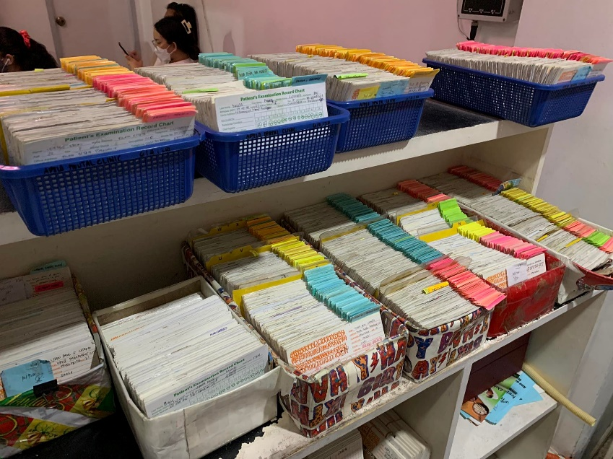Apelo Dental Clinic still uses physical storage and uses index cards for their patients. Patients queue up starting at 3 am to be given a number that would determine their place in line to be served. A secretary organizes the index card and other files like dental x-ray which she will hand to the doctor when it’s the patients turn in the operating room. Whenever a dentist needs to take pictures or videos, the dentists’ transfer and save it on iCloud.

Fig. 1 Apelo Dental Clinic's file system for patient information

1. List of Processes

Table 1  
 List of Processes in the Current System

|  |  |  |
| --- | --- | --- |
| Process ID | Process Name | Process Details |
| P001 | Patients list their name in a paper | Patient queues up as early as 5 am to list their name, procedure, and date of arrival in a sheet of paper which will be the basis of numbered card. |
| P002 | Getting numbered card | At 8:30 am, the front-desk staff will give all the patients their numbered card based on date of arrival. |
| P003 | Waiting at the lobby | Patients who get smaller number will wait at the lobby while some patients leave the clinic for a while and comes back at a later hour |
| P004 | Retrieval of index card | Front-desk staff will retrieve the patient’s index card that contains all the patient’s information. If not found, the patient will fill another index card. |
| P005 | Fill-up an index card | New patient or those who haven’t found a record (lost) will fill another index car |
| P006 | Next patient | Once a patient in the operating area is done, new patients will go inside, and the front-desk staff will hand over the index card to a doctor. |
| P007 | Looking at the index card | Doctor will look at the index card to see all the needed information such as recent procedure done, visual teeth model etc. |
| P008 | Procedure starts | Once diagnosis is made, all the necessary procedure will be made or depends will be agreed upon |
| P009 | Procedure done | When the procedure is done, the doctor will write the payment cost in a small piece of paper clipped in the index card. |
| P010 | Paying the procedure | The patient will go to the accounting staff to pay the amount, when their money is not enough, the clinic allows balances to be paid on the next visitation. |
| P011 | Record the payment | Accounting staff will record all the payment made in that day in a paper and records the payment info in the index card |
| P012 | Putting back the index card | At the end of the day, all the index cards will then be rearranged again to its tray holder. |
| This table shows the chronological day to day process of the clinic from the moment that patient queues to list their name in a paper to getting their number, finishing their procedure, paying, and leaving the clinic. | | |

1. SWOT Analysis



Fig. 2 SWOT Analysis of Apelo Dental Clinic

1. Fishbone Diagram Analysis

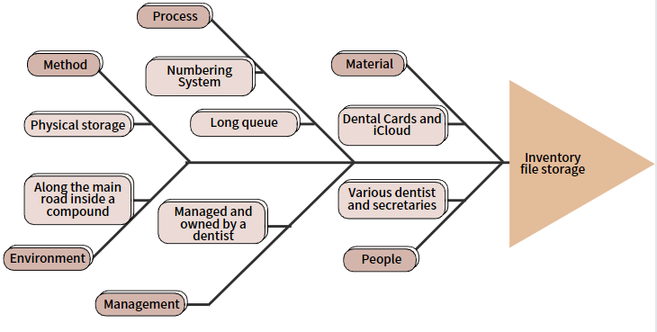

Fig. 3 Fishbone Diagram of Apelo Dental Clinic

# Proposed Solution

1. Technical Background

ADENICSY will be automating the process of scheduling a patient for a slot within a day and the storage of patient information and the process related to it such as inputting additional medical records, adding payment records etc. This will result to increase efficiency, minimize risk of data loss, and less physical storage consumed by the records.

The software will be developed in code using a computer and a mobile device that will then be tested and used on mobile phones, tablets, and computers. The main functions will be created using various coding languages as well as the design and overall look of the application. For software, the researchers will possibly use Visual Studio Code, Notepad++, Jupyter, GitHub or other hosting platforms. For the peopleware, the required staff as well as the owner will be taught about the application or be provided with documentation to avoid errors and confusion. For the network, the developers would like the files, pictures, videos, and other documents to be transferrable via WIFI, Bluetooth, USB, and even downloading through internet storages such as Google Drive and iCloud. In terms of data syncing in all the devices, information should be consistent via the devices used in the clinic through routers while available data on the website from the patient’s side accessing it remotely should be syncing as there is an internet connection available.

1. Feasibility

### Operational Feasibility

Apelo Dental Clinic's (ADC) patient information are stored in the index card that are filed in a box. As the team propose to Doctor Denroe the initial plan to implement a website with the main feature to address the appointment system, he declines to it due to the reason that there's no fix time for each patient's procedure. He rather suggests having a database for patient's information due to several problems that the traditional file system is causing. Hence, the support of the management to the project is certain.

Soon as the clinic will transition from index card file system to computerized, there would be a need for testing and brief training for navigation and how-to of the system.

The secretary and staff in payment section has the knowledge of using computer programs, while the doctors have no problem in transitioning to tablet-based information retrieval as they all agreed in implementing the application and are using smartphones.

Documentation will also be available to the development of the application so that the future IT who will maintain the program will not have a hard time to make modifications on it.

### Economic Feasibility

ADC's facility is already equipped with desktop computer, Wi-Fi and printer which are the initial hardware equipment needed for the project. However, the tablets which are the alternative for index card are still needed to be canvas for estimated price, nevertheless, Doc Denroe was already informed about the possible cost as the idea of tablets are suggested by him.

There will be no need for any software subscription for the development of the system as the language for development will be open-source and the database will be RDBMS of phpMyAdmin via XAMPP.

Although the development of the project will not assure to increase the profit of the clinic, customers’, and employees' satisfaction for faster waiting time due to fast retrieval of information and paperless transaction will outweigh the cost of the project development.

### Technical Feasibility

Tablet is the only hardware that the clinic lacks for the initial assessment of hardware requirements, nonetheless, tablet can be easily purchased today with lower specifications that can support the program to be installed. Since RDBMS is the database needed for the application, the future needs for memory capacity of the program are more likely to be contained in free database software as they offer large memory capacity in terms of clinic-size database.

1. Requirements Analysis

### Product Vision

Fig. 4 Product Vision for Patient Users



Fig. 5 Product Vision for Doctor Users



Fig. 6 Product Vision for Front-desk Staff User



Fig. 7 Product Vision for Accounting Staff User

### User Classes and Characteristics

Table   
 User Classes and Description in the Software

|  |  |
| --- | --- |
| Roles | Description |
| Doctor | This user can modify medical and personal information of a patient, upload pictures and other files, access payment information, and input payment details during a procedure. |
| Website Visitor | This user is a web visitor who can see the general information of the clinic, services, contacts and can register through the website to become a patient user. |
| Patient | This user has the description of the *website visitor,* but he/she can make an appointment, modify personal info, request an information, and access necessary information about him/ her at the clinic. |
| Front-desk Staff/ Secretary | This user can access patients’ information and can perform Create, Read, Update and Delete (CRUD). She can also modify the schedule of the doctor in the appointment page and sends the necessary notification via SMS through the system. |
| Accounting Staff | This user can access payment records, and update information like amount paid, balance, credit, etc. She can also generate a sales report through day/ month/ year depending on time constraints. |
| These users are the prospected user of the website/ system and what are some of the things that they can do in it | |

### Product Backlog

Table   
Product Backlog of ADENICSY

|  |  |  |  |  |
| --- | --- | --- | --- | --- |
| Product Backlog | | | | |
| ID | **As a…** | **I want to be able to…** | **So that…** | **Priority** |
| 1 | Front Desk staff | See the status of the patient queue in appointment slot list | I can maintain number of patients for a certain doctor without making them wait for long | Should |
| 2 | Front Desk staff | create, read, update, and delete patient information in the system | information can be organized. | Should |
| 3 | Front Desk staff | change the list of doctors in a specific day in the appointment page | patient will be informed ahead of time about the availability of ae doctor | Should |
| 4 | Front Desk staff | send an SMS notification to a patient | they will be informed about the necessary information like changes in schedule, monthly visitation date, etc. | Should |
| 5 | Doctor | view and examine my patients’ personal information | I know what to advise and fix | Must |
| 6 | Doctor | view and examine my patients’ teeth model | I can easily have an overview of their problem | Must |
| 7 | Doctor | view my patients’ medical history | I know what procedures to do with treating the patient | Must |
| 8 | Doctor | view and examine my patients’ radiographs, pictures, etc. | I can have a better understanding of their situation | Must |
| 9 | Doctor | put the necessary information in my patients’ medical history | other assigned doctors can examine what I have done with the patient | Must |
| 10 | Doctor | modify the color of a certain part of the tooth in a rendered model | I and other doctors can easily have an idea of the patients’ teeth information and situation | Should |
| 11 | Doctor | put notes and the necessary information on a certain tooth | I and other doctors can have more detailed information about a certain condition | Should |
| 12 | Doctor | limit the patients I handle in a day | I would not be exhausted and lessen the confusion with whatever treatment I give to patients | Should |
| 13 | Doctor | input the total cost that the patient needs to pay | Patient can pay at the accounting without bringing paper. | Should |
| 14 | Accounting staff | open remote payments | People can pay anywhere | Could |
| 15 | Accounting staff | generate payment per procedure | They can easily know how much they will pay | Should |
| 16 | Accounting staff | know if the patients paid on time | I can monitor who is paid, unpaid, and some that have a remaining balance | Should |
| 17 | Accounting staff | generate the sales of the clinic at the end of the day | I can see the sales at the end of the day | Could |
| 18 | Patients | see my payment records | to view and calculate my payment and to know if I have a balance | Should |
| 19 | Patients | easily acquire a slot for a procedure or treatment | I will not waste my time waiting | Should |
| 20 | Patients | request for my personal information | I have an idea and plan with the doctor for my next procedure | Could |
| 21 | Patients | select my preferred doctor if they are available | there would be little to no confusion with my procedures or treatment | Could |

### A picture containing diagram Description automatically generatedPrototype

Fig. 8 ADENICSY Homepage from the Perspective of a Web Visitor

This is the first page of ADENICSY website from a web visitor’s perspective. He/ She can see here the general information about the clinic and has the option to register/ sign in where he/she will be given more capabilities on the website.

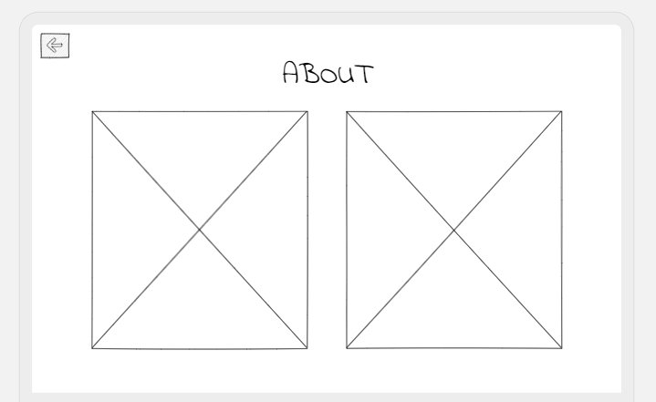

Fig. 9 ADENICSY About Page

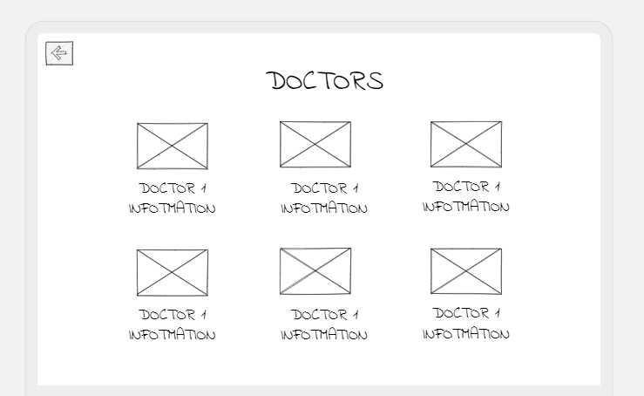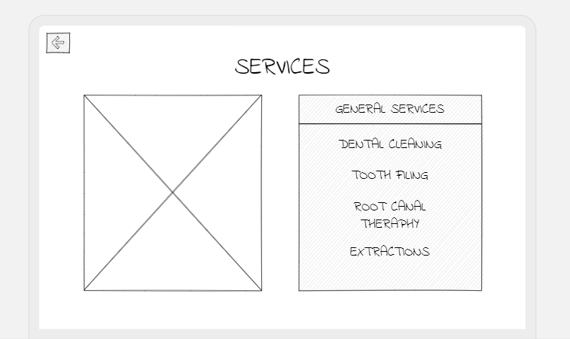

Fig. 10 ADENICSY Services Page

Fig. 11 ADENICSY Doctor's Information Page

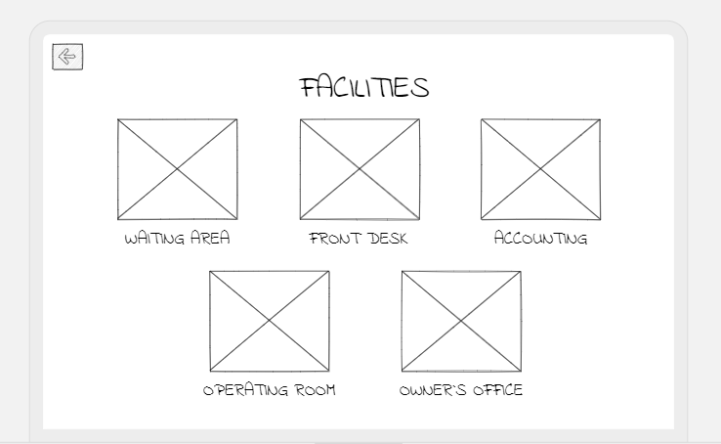

Fig. 12 ADENICSY Facilities Page

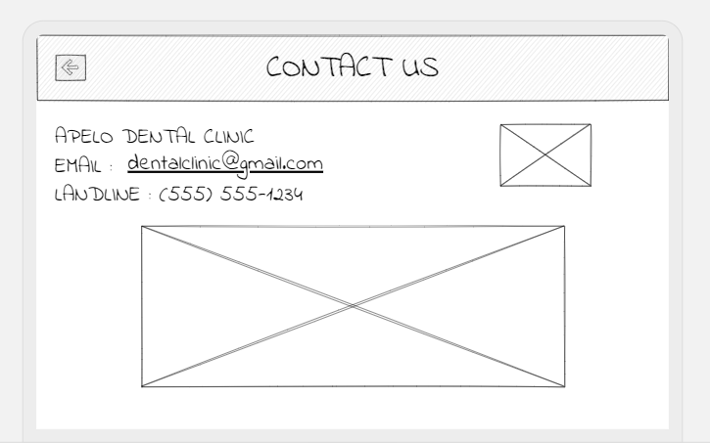

Fig. 13 ADENICSY Contact Information Page

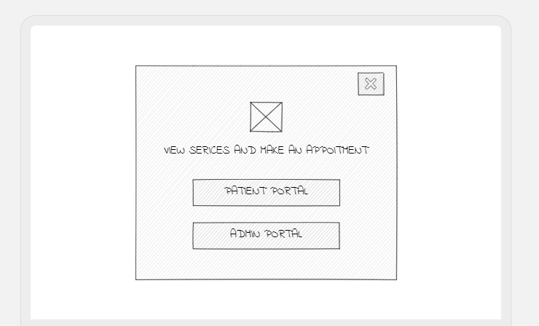

Fig. 14 ADENICSY Initial Page from Sign in Button

Figure 9 – 11 is the page when the user clicks a certain tab in the Home Page from figure 8. When the visitor clicks on the Sign in Page, he will be prompted whether he will be logging in as Patient or Admin since this is where the interface will differ depending on who the user is. After clicking the “Patient Portal” button, the user will then be prompted to login or register as can be seen in figure 15.

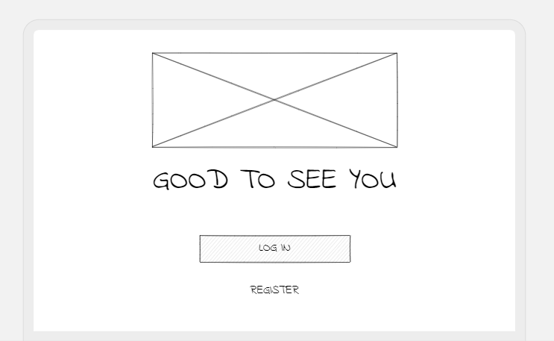

Fig. 15 ADENICSY Login/ Register Page

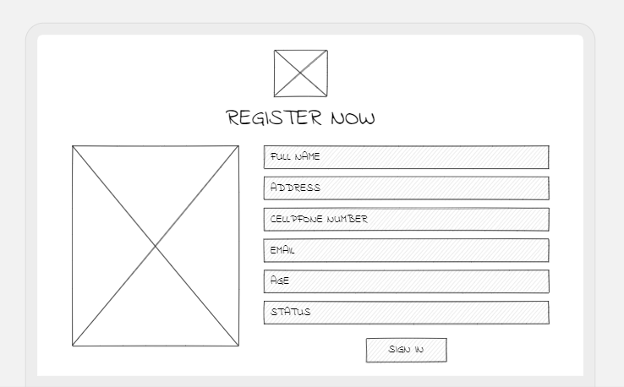

Fig. 16 ADENICSY Register Page

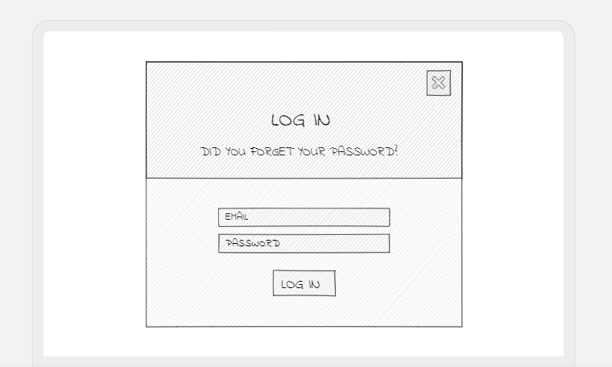

Fig. 17 ADENICSY Login Page

Once logged in, the website will change on the layout below. A menu bar can be found on the upper right corner of the screen where patient can modify his/her personal information, request a form, and make an appointment.

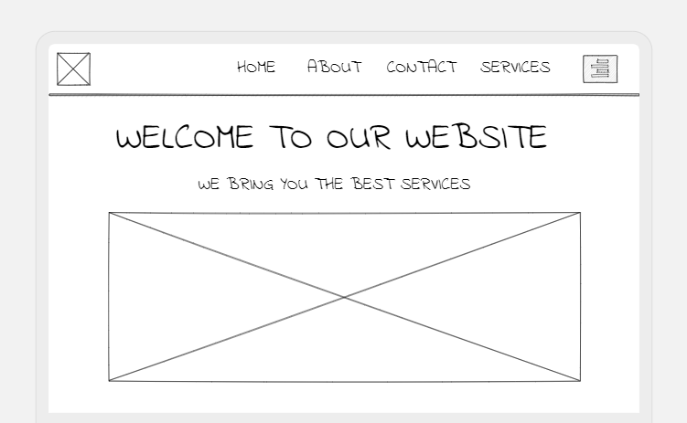

Fig. 18 ADENICSY Home Page Once Patient Logged In

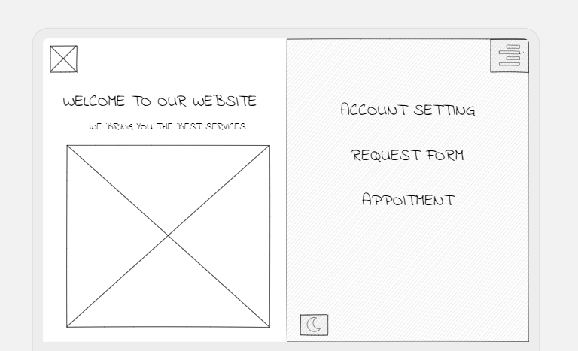

Fig. 19 Home Page When Menu Bar is Clicked

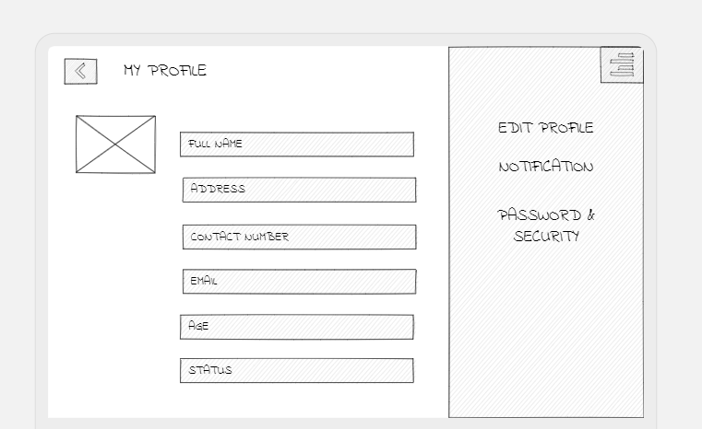

Fig. 20 Account Settings Page

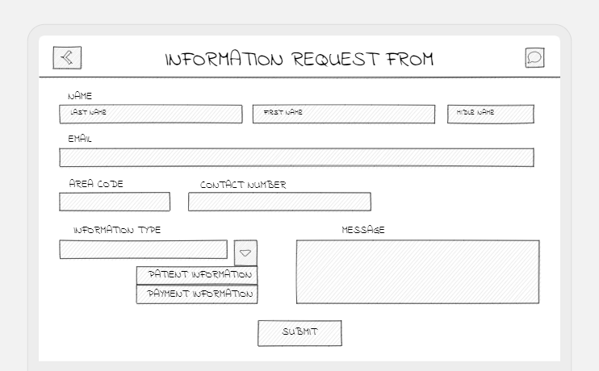

Fig. 21 Information Request Page

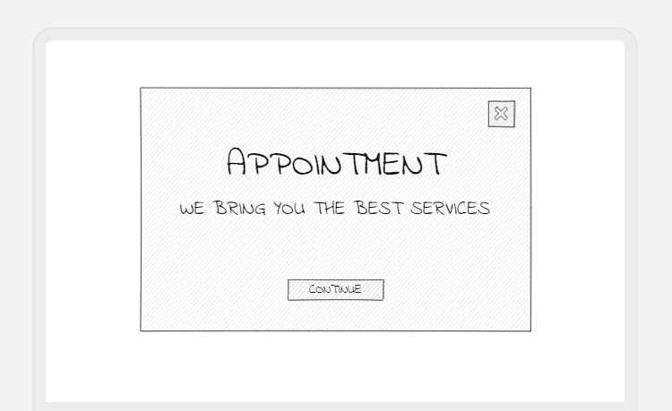Figure 20 – 22 above is the page when a certain tab is clicked on the menu bar in figure 19 above. The following page is the flow when the user will make an appointment after clicking the “Continue” button in figure 22.

Fig. 22 Appointment Page

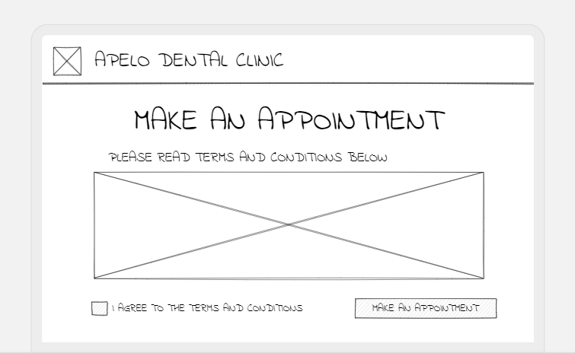

Fig. 23 Appointment Terms and Condition

After ticking the box in figure 23 stating that the patient is agreeing to the terms and condition of the appointment system of the clinic, she will then be able to proceed in seeing the available date of the appointment like the one in figure 24, in this case the available is the schedule for the following 7 days, but it will still be modified based on how the client wants it to be.

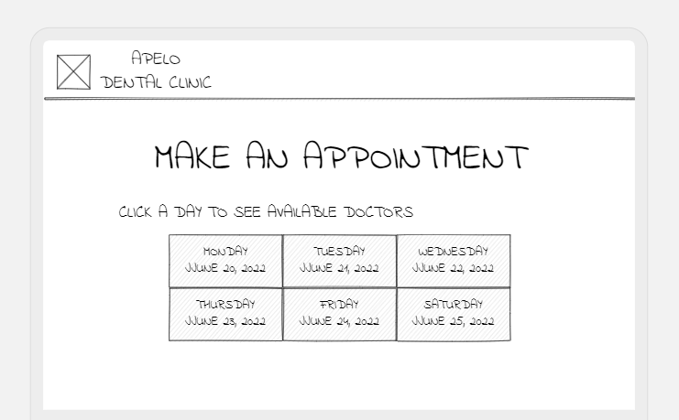

Fig. 24 Appointment Dates

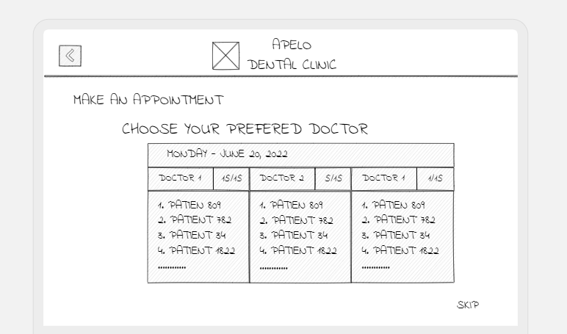

Fig. 25 Available Doctors on a Certain Day

Figure 25 shows the available doctors for a specific day clicked by the patient. Number of occupied slots can be seen in the side of the doctor’s name and the list of patient ID who reserved a slot for that day. They can be able to choose a doctor by clicking on the column or just skip it (lower right corner) where system will automatically choose the doctor with lesser number of patients.

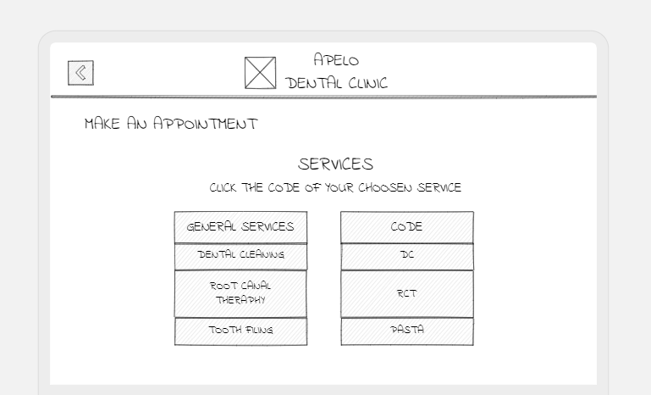As per the current process of the clinic where patients list their name on the log sheet where services are also included. Patient will be able to choose 1 service that they think is their main intention, although all of this can change based on the doctor’s diagnosis to the patient.

Fig. 26 Choosing Service



Fig. 27 Services Page

After clicking the specific service, the patient will then be prompted to recheck all his information especially the numbers that he/she enters in the personal information page that will automatically fill the information in the next page at figure 28.

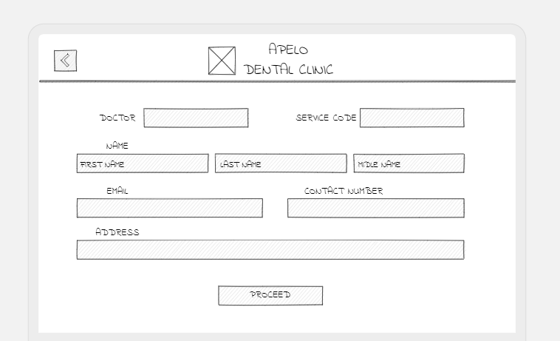

Fig. 28 Filling Information for Appointment

After filling the necessary information, the patient will be shown a “Thank You Page” saying that he/ she will receive a confirmation message via SMS and will have a home button to return to home page as shown in figure 29 below.

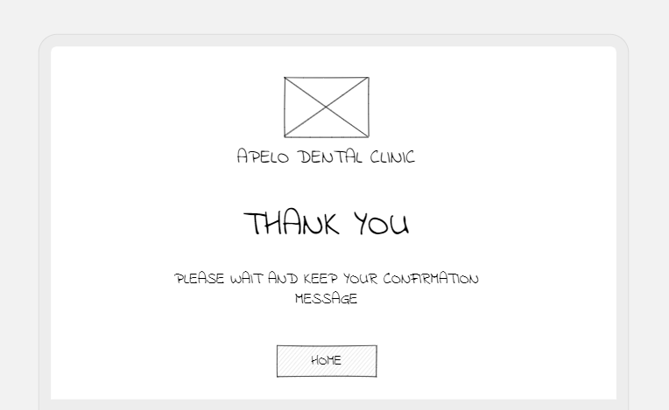The following prototype is the page when user from figure 14 will choose admin portal

Fig. 29 Thank You Page

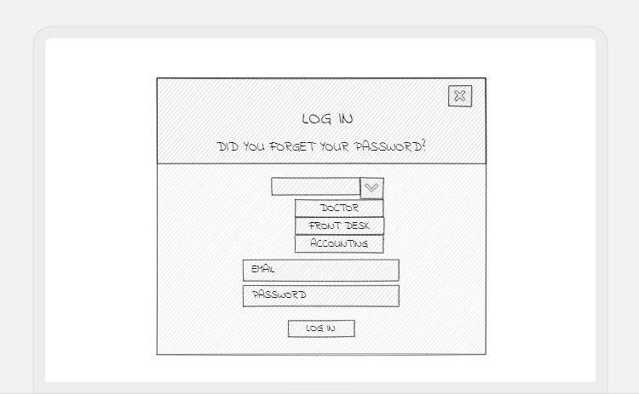

Fig. 30 Admin Login Page

Figure 30 is the log in page for the admin, it has a dropdown button to specify which admin is logging in that will dictate which capability a certain user will have. Figure 31 is the initial home age from admin’s side

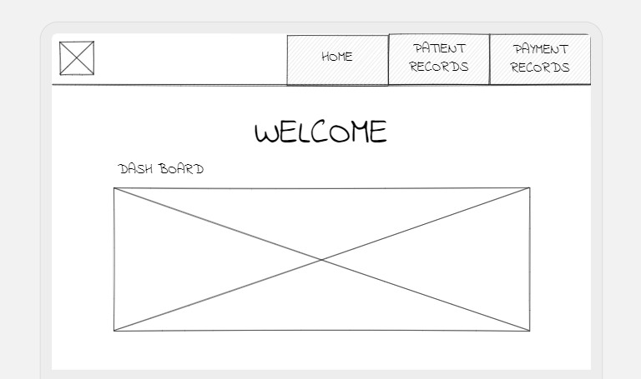

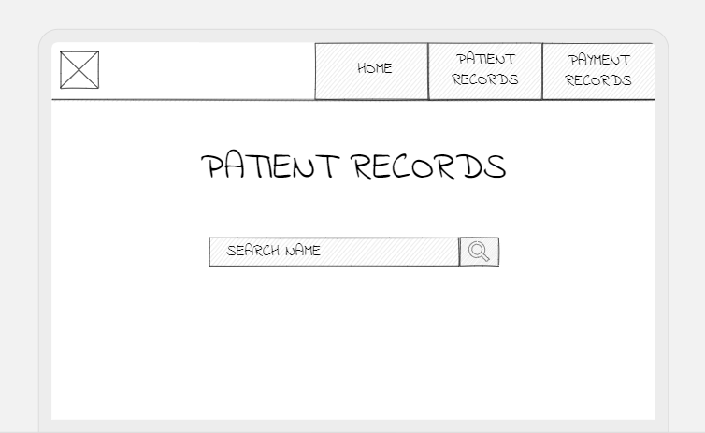

Fig. 31 Patient Records Page

Fig. 32 Admin Home Page

When “Patient Records Tab” is clicked in the tab from figure 30, a search bar will be shown that will allow a user to view patient records. For example, “Ana” is the written key word in the search bar, all the matching patient name with Ana will be show with all necessary information shown that can uniquely identify here aside from last name, such as birthdate and picture.

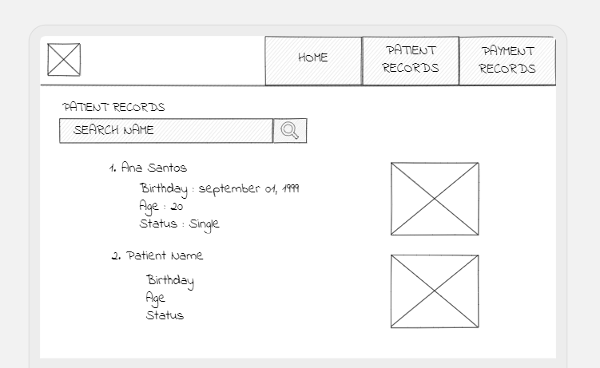

Fig. 33 Search Result Page

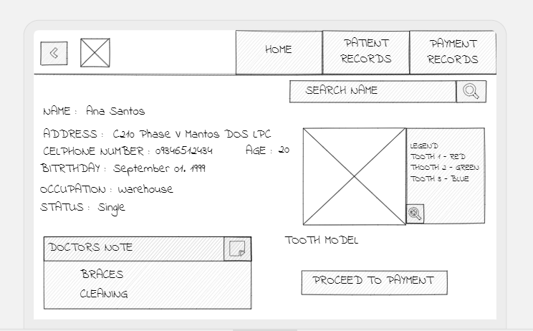

Fig. 34 Patient Information Page

Figure 34 is the page when a certain result is clicked from figure 33- that is the patient information which represents the index card in the current system. Patient information is on upper left side, visual teeth model on the upper right side and doctor’s most recent medical notes can be seen in the lower left corner that can be clicked to zoom in and show previous records. Visual teeth can be zoomed as well to see a more detailed representation of the teeth whereas each tooth is divided and into parts that can be colored and inputted of information. At the lower right corner is the “Proceed to Payment” button where doctor can enter the payment details.

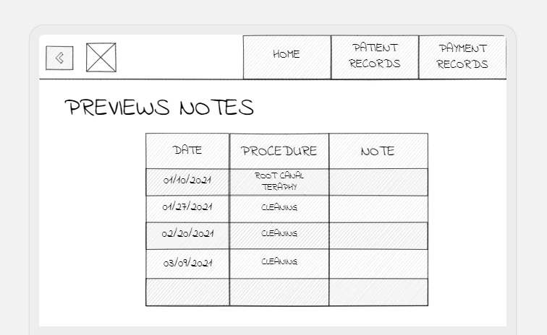

Fig. 35 Detailed Medical Notes of the Doctor

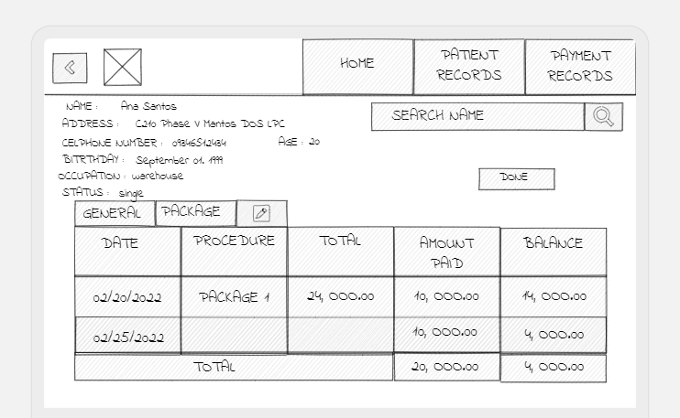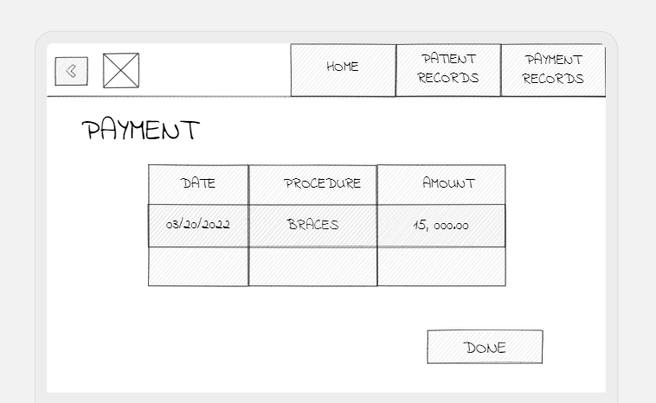Once “Done” button is clicked in figure 36, the payment details will then be synced to patient’s payment record that the accounting can see in the “Payment Records” page at figure 37. Accounting can enter the amount paid because some patients are allowed to pay partial amount. Payment record will be divided into package category and general records as per our interview with the staff that they are recorded differently.

Fig. 36 Payment Details Page

Fig. 37 Payment Records Page

### Product Roadmap

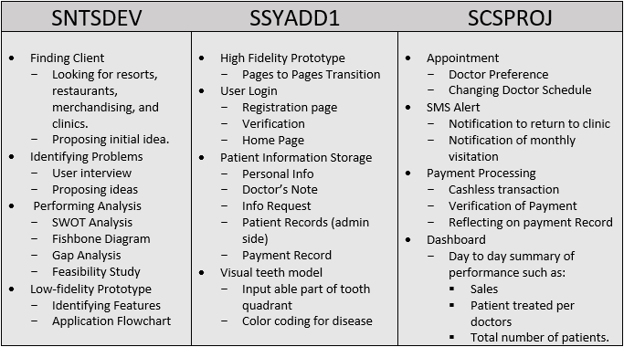The product road map is based on the three consecutive subjects of APC’s Project-Based Learning (PBL). The first column with ‘SNTSDEV’ which stands for Introduction to Systems and Design have milestones that is more on identifying problems and making analyses to find its root cause. The low-fidelity prototype is the last milestone in this part which represents the initial idea of how the developers will make the solution for the said problem. While the other two columns will start from developing a high-fidelity prototype and developing the actual software.

Fig. 38 Product Roadmap

### Release Plan

This is the release plan of the developers based on the product backlog at section 4.3.3. As of now, there’s still nothing completed from it, but the developers are planning to do the necessary pages from release 1 before SSYADD1 starts to better plan the more complex features and reiterate fast for testing and refinement.

**Release 1**

Patients can visit the website.

Patients can register and login.

Patients can see the mission, vision, services, and other general information of the clinic.

**Release 2**

Front-desk staff can transfer records from index card to the system.

Doctors can search for a patient information.

Doctors can modify patient information in the storage.

Doctors can input information on each tooth part in the visual teeth model.

Patient request for information.

Doctors can approve information requests.

Accounting can add payment records of the patient.

**Release** 3

Front-desk staff can change doctor’s availability in the appointment feature.

Front-desk staff can release an appointment date for the coming week.

Front-desk staff can send an SMS alert to notify patient to come to the clinic.

Front-desk staff can send an SMS alert to notify patient when their appointment is cancelled due to doctor’s emergency or other incidents.

Front-desk staff can send an SMS alert to patients for monthly visitation.

Patient can choose a specific doctor in the appointment.

Patient can make payment online

Patient can make cashless transaction

Doctor can see performance summary in the dashboard

# Conclusion

Introduction to Systems and Designs (SNTSDEV) journey started from finding our client. The developers reached out several businesses such as resorts, merchandising and dental clinic offering them computational solutions for their business. Convincing business owners to adapt to computational solution requires dedication and courage to the developers. With limited knowledge to the area, we must need to know the domain knowledge of the business that we will be providing solution and pitch idea that will persuade them to work with us, luckily, we got the dental clinic to agree.

Apelo Dental Clinic (ADC) is our client, their main problems are the long waiting time of patients and the manual storage of patients’ information in an index card. At the first glance in the problem of long waiting time, the developers thought that it just needs an appointment system with specific time where a patient can schedule and attend to but as we make analyses to the problem and conduct our interview with the staff and patients, we found out several factors that affecting it and what are our limitations in handling the problem. We listed the factors affecting the long waiting time of the patient in a board after we made our interview and analyses which you can see at appendix C, figure 55, and these are: 1. Line cutters, 2. No specific treatment time for patients, 3. Preferred doctor 4. Number of available doctors depend on days, 5. Patients often go to the clinic during salary period. The biggest factor to patient’s long waiting time is the unspecified treatment time for patients, and this factor is also the one which either the developer or the management has control over because this is just the nature of dental clinic; people will go to the clinic and the doctors are the one to determine which treatment will they get determining the duration of the treatment. Nevertheless, other factors that’s causing the long waiting time can be handled through appointments by means of scheduling a slot through a specific doctor and patients can see the current patient being served through the website in real-time, and when they are 5 patients away from being served, they will also receive an SMS notification telling them that they need to come to the clinic already. Schedule of doctors should also be submitted ahead of time so that the front desk staff can do prior modifications before making the appointment date available to the patient’s end, there will also be terms and conditions to the patient about the appointment to keep things regulated and ADC’s employees will not get overwhelmed. Dashboard will also be implemented to keep track of the clinic’s performance, the latest interview conducted with the employees said that there are even more number of patients in the middle of the week before salary period, meaning that tracking performance is crucial to make wise decisions like adding more doctors when patients to doctors ratio is not sustainable anymore, or maybe there’s need to reschedule other customers who have adjustment procedures to other days of the week to spread their number and employees can work optimally.

At the first meeting with ADC’s owner - Dr. Denroe Apelo, he didn’t really like the idea of appointment system as for the long run that they’ve been operating, several techniques of queueing and appointment system have been implemented, but none works well that address the problems of waiting time. Hence, he discussed more his idea of replacing the index card as their medium of storing patient’s information to a tablet where they can easily search for a patient’s information instead of using an index card. The developers also go on their process on how index card goes from day-to-day transactions and here ‘s how. When a patient is near the line to be served, the front desk staff will find his/her index card that is filed in a tray, if lost or new patient he will be asked to fill an index card with his personal information. When it’s the patient’s turn already, the front desk will hand the index card to the doctor clipped with a small piece of paper where the payment details will be written. The doctor will then use the index card to obtain necessary information from a patient, for example, he will look at the recent medical procedure done to an old patient by looking at the medical notes that is left by the previous doctor who handles the patient so that he will better understand the case. After the treatment, he will write in the piece of paper that is clipped in the index card the procedures done and the total cost. The patient will bring it together with the index card to the accounting staff to pay the amount or ask the staff if they can’t pay the entire amount. The accounting staff will be the one to write the payment info in the index card and she will also write it in another paper for the sales report. At the end of the day, the index card will then be recompiled in the tray where it is stored. With those details, aside from digitalizing the patient information from the index card, the system will also provide features that will improve the processes related to it, things like inputting payment details on the doctor’s side and syncing it real-time to the device opened in the accounting staff so that when the patient will be paying already, they will no longer bring the index card and piece of paper. Generating sales report will be easier as well if the accounting staff can download a sales information in just a click of a button depending on a configured time constraints.

So far, none from developer’s objectives have been achieved yet. Nevertheless, what they have been formulated as solution for the problems so far is a good way to go and start doing their project. Since the key to agile software development is early release of minimum viable product (MVP), we will start developing the homepage of the clinic before SSYADD1 starts so that we can focus on developing the complex features that we still need to learn. The product backlog and prototype will also be prioritized at the start of SSYADD1. Significantly, the appointment and digitalization of index card is one of the most valuable features that we need to develop to address the stated problems above and supplementary to these are the SMS notification and the visual teeth model, while the dashboard is also significant in addressing the long waiting time of the patients.

Therefore, features mentioned above are crucial in delivering solution to the problems of ADC, thus, early iterations of project are a must, and the developers should stretch more their learning curve to deliver the solution at the end of the timeframe. The current plan of the developers is to refine the backlog and do the project little by little while making appropriate revisions along the way.

# References

|  |  |
| --- | --- |
| [1] | C. D. B. Nimes, L. B. Hidalgo and M. L. Sacramento, "Dental Clinic Management System," Nueva Ecija, 2019. |
| [2] | F. Masic, "Infomation Systems in Dentistry," ACTA INFORM MED, Faculty of Dental Medicine, Medical Universitry of Vienna, 2011. |
| [3] | My Dental Clinic, [Online]. Available: https://dentalclinicapp.com/#features. [Accessed 29 May 2022]. |
| [4] | Klinika.ph, "Simple Clinic Management System Designed for Doctors," [Online]. Available: https://klinika.ph/. [Accessed 30 April 2022]. |
| [5] | Plato, "Build a Collaborative Dental Practice," [Online]. Available: https://platomedical.com/whitepapers/collaborative-clinic-dental. [Accessed 2020]. |
| [6] | MYWAM SDN BHD, "Doctor Assist Practical Clinic Management Solution," [Online]. Available: https://wammap.com/doctor-assist-software/?gclid=Cj0KCQjwspKUBhCvARIsAB2IYuvJ0_B2gPyKj3wrDXUboltV8l54beFGjUrDe5iMH9Rik2AB2KJAheUaAi8AEALw_wcB. [Accessed 05 May 2022]. |
| [7] | Centaur Solutions Enabling, "Dental4Windows," [Online]. Available: https://www.centaursoftwareuae.ae/. [Accessed 05 May 2022]. |
| [8] | Plato Medical, "Plato Dental Clinic's Operating System," [Online]. Available: https://platomedical.com/dental-practice. [Accessed 05 May 2022]. |
| [9] | Topline, "Clinic / Medical Center Management Software ( E-claim & E-Prescription Ready)," [Online]. Available: https://www.toplineuae.com/products/clinic-software-dubai/. [Accessed 05 May 2022]. |
| [10] | J. Wordingham, "Patient Appointment Systems In Hospitals," 27 Jan 2021. [Online]. Available: https://www.qmatic.com/blog/appointment-systems-in-hospitals. [Accessed 28 May 2022]. |
| [11] | A. Abburaya, A. Al Marzouqi, I. Al Ayadeh, A. Albqaeen and S. Mubarak, "Evolving a Hybrid Appointment System for Patient Scheduling in Primary," International Journal on Emerging Technologies, 2020. |

# Appendices

## Appendix A: Roles and Responsibilities

Table 4   
Roles and Responsibilities

|  |  |  |  |
| --- | --- | --- | --- |
| Name | Roles | | Responsibilities |
| Alfonzo Louise De Vera | Leader, Group representative | PowerPoint creation, Review of related literature, Project Context, Current systems, List of processes, GAP analysis, Product backlog | |
| Janssen Pedrola | Client locator, Paper Proofreading | | Methodology, PowerPoint creation, Review of Related Literature, Plan to Integrate CAMMS, Statement of the Problem, Objectives, Feasibility SOP progression, Release Plan |
| Guiler Marion Regalado | Prototype Creator | | Significance of the project, PowerPoint Creation, Review of Related Literature, Requirement analysis, Roles, Description |
| Earl Eufimeah Dahinao | Documentation Lead | | Documentation, Minutes of the meeting, Introduction, PowerPoint creation, Review of Related Literature, Proposed Solution, Theoretical Background, Technical Background |
| Patricia Anne Meltran | Design Lead | | Minutes of the meeting, Methodology, PowerPoint creation, Review of related literature, Scope and Limitation, Prototype Digitalization |
| This table shows the roles of everyone in the group and parts that they contributed to the paper. | | | |

## Appendix B: Minutes of the Meetings

The minutes of the meeting from May 5, 2022, to June 2, 2022, will be shown in the table 5 below which dates, participants, duration, and meeting agenda are included. Pictures from random meetings, either face to face or online will be shown following the table with brief description of the meeting’s agenda.

Table 5   
Minutes of the Meetings

|  |  |  |  |  |
| --- | --- | --- | --- | --- |
| Meeting ID | Date | Participants | Duration | Agenda |
| M001 | May 5, 2022 | Earl Eufimeah Dahinao  Patricia Anne Meltran  Janssen Pedrola  Guiler Marion Regalado | 1 hour and 2 minutes | * Comment Matrix * New Group name |
| M002 | May 12, 2022 | Earl Eufimeah Dahinao  Patricia Anne Meltran  Alfonzo Louise De Vera  Janssen Pedrola  Guiler Marion Regalado | 1 hour and 9 minutes | * Slide Deck for Apelo Appointment System * Additional RRLs |
| M003 | May 14, 2022 | Earl Eufimeah Dahinao  Patricia Anne Meltran  Alfonzo Louise De Vera  Janssen Pedrola  Guiler Marion Regalado | 43 minutes | * Statement of the Problem * RRLs * Task Delegation |
| M004 | May 16, 2022 | Earl Eufimeah Dahinao  Patricia Anne Meltran  Alfonzo Louise De Vera  Janssen Pedrola  Guiler Marion Regalado | 42 minutes | * Appointment System Proposal |
| M005 | May 17, 2022 | Earl Eufimeah Dahinao  Patricia Anne Meltran  Alfonzo Louise De Vera  Janssen Pedrola  Guiler Marion Regalado | 1 hour and 3 minutes | * Slide deck for appointment proposal |
| M006 | May 18, 2022  (Client Meeting) | Earl Eufimeah Dahinao  Patricia Anne Meltran  Alfonzo Louise De Vera  Janssen Pedrola  Guiler Marion Regalado | 20 minutes | * Current Progress of the project development * General Questions about the topic * Questions about the implemented appointment system before * Propose Appointment System |
| M007 | May 18, 2022 | Earl Eufimeah Dahinao  Patricia Anne Meltran  Alfonzo Louise De Vera  Janssen Pedrola  Guiler Marion Regalado | 20 minutes | * Meeting, Presentation, and Consultation with an adviser |
| M008 | May 18, 2022 | Earl Eufimeah Dahinao  Patricia Anne Meltran  Alfonzo Louise De Vera  Janssen Pedrola  Guiler Marion Regalado | 33 minutes | * Current Progress of the project development * General Questions about the topic * Questions about the implemented appointment system before * Propose Appointment System |
| M009 | May 19, 2022 | Earl Eufimeah Dahinao  Patricia Anne Meltran  Alfonzo Louise De Vera  Janssen Pedrola  Guiler Marion Regalado | 33 minutes | * Current Progress of the project development * General Questions about the topic * Questions about the implemented appointment system before * Propose Appointment System |
| M010 | May 23, 2022 | Earl Eufimeah Dahinao  Patricia Anne Meltran  Alfonzo Louise De Vera  Janssen Pedrola  Guiler Marion Regalado | 2 hours | * Task division for clinic staff and patient interview. * Creating appropriate questions for the specific interviewee * Listing all requirements for the final paper. * Setting deadline for previews task division. * Listing agendas for the next meeting on May 30. * Revision of SOP progression. |
| M011 | May 25, 2022 | Earl Eufimeah Dahinao  Patricia Anne Meltran  Alfonzo Louise De Vera  Janssen Pedrola  Guiler Marion Regalado | 26 minutes | * Reminders for the agenda for the meeting on May 30. * Finalization of minutes and division. |
| M012 | May 30, 2022 | Earl Eufimeah Dahinao  Patricia Anne Meltran  Alfonzo Louise De Vera  Janssen Pedrola  Guiler Marion Regalado | 33 minutes | * Planning to have onsite meetings, especially for paper prototypes. * Sending SOP progression to the adviser to check. * Brainstorming for the features for the prototype. * Parts division for the product backlog. |
| M013 | May 31, 2022 | Earl Eufimeah Dahinao  Patricia Anne Meltran  Alfonzo Louise De Vera  Janssen Pedrola  Guiler Marion Regalado | 40 minutes | * Discussion of the root cause of the problem. * Scaling the problems that the developers notice. * Discussion of the process of the appointment system. * Topic that must be included in the introduction of the paper. * General objectives. * Discussion about sop and objectives. |
| M014 | May 31, 2022 | Alfonzo Louise De Vera  Patricia Anne Meltran  Guiler Marion Regalado  Janssen Pedrola | 7 hours | * Revision of SOP progression. * Creating product vision, product backlog, product roadmap, and release plan. * Starting to build a prototype. |
| M015 | June 2, 2022 | Alfonzo Louise De Vera  Earl Eufimeah Dahinao  Patricia Anne Meltran  Guiler Marion Regalado  Janssen Pedrola | 7 hours | * Revision of SOP progression. * Finalizing features of the prototype. * Finishing prototype for patients and doctors. * Finalizing final paper. * Discussion for the video. * Discussion for the slide deck. |
| The meeting included in this table are group meeting, meeting with the adviser, and meeting with the clients. | | | | |

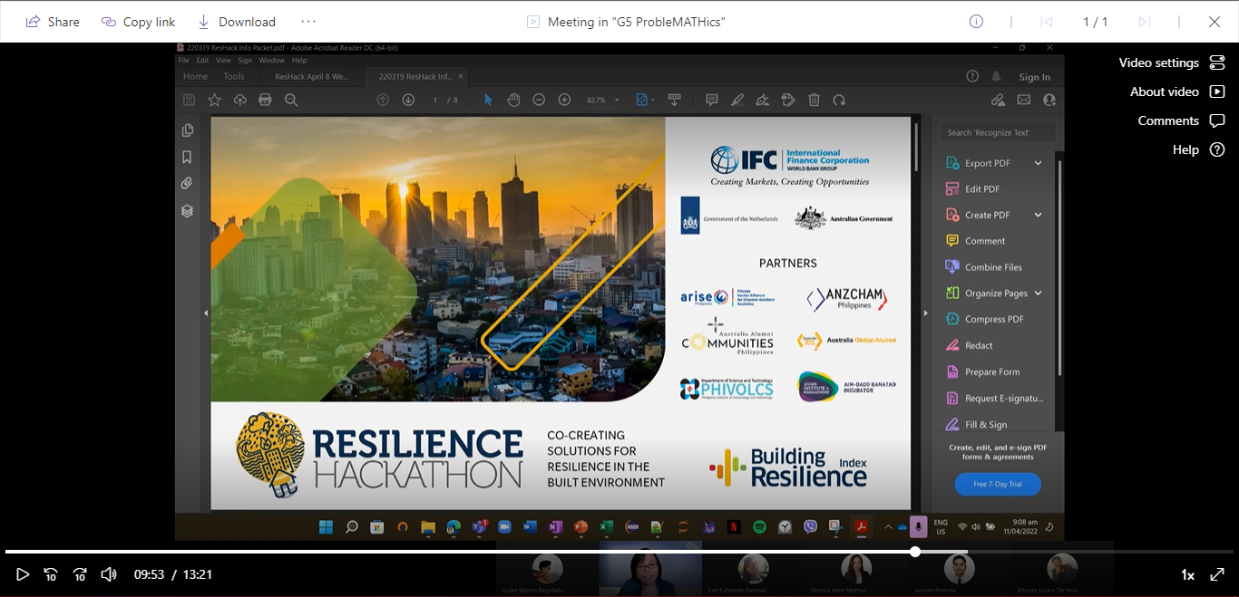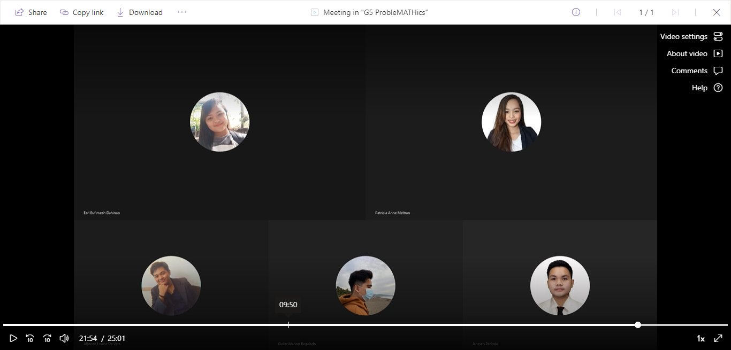

Fig. 39 Screenshot from 2nd Recorded Meeting dated April 11, 2022

Fig. 40 Screenshot from 1st Recorded Meeting dated April 05, 2022

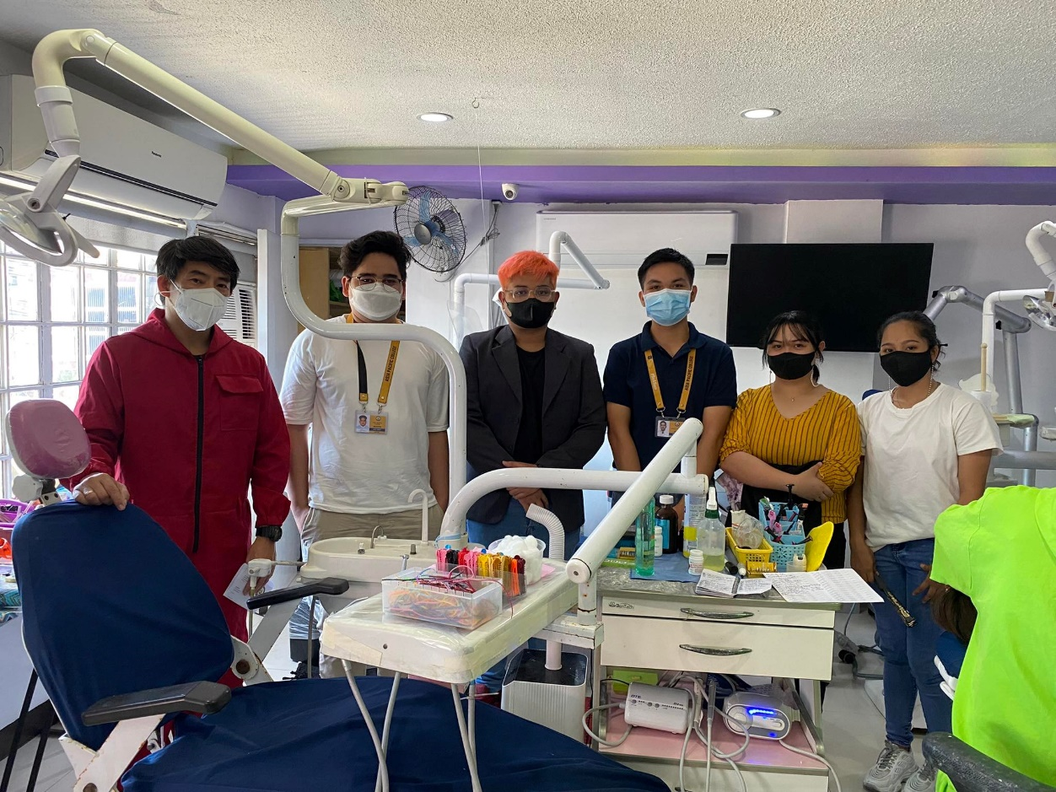

Fig. 41 First face to face meeting with the client dated April 25, 2022

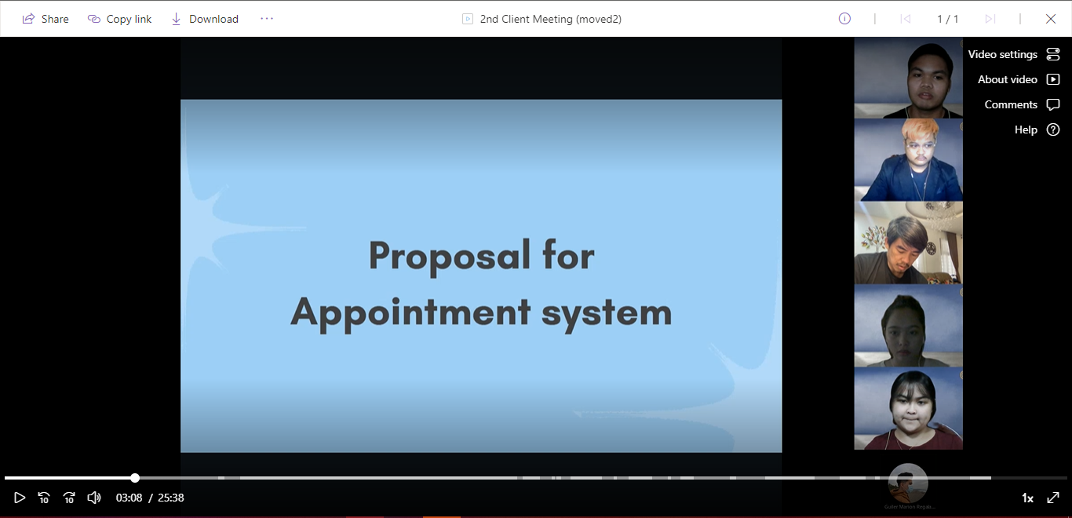

Fig. 42 Client meeting for proposal of appointment system dated May 5, 2022

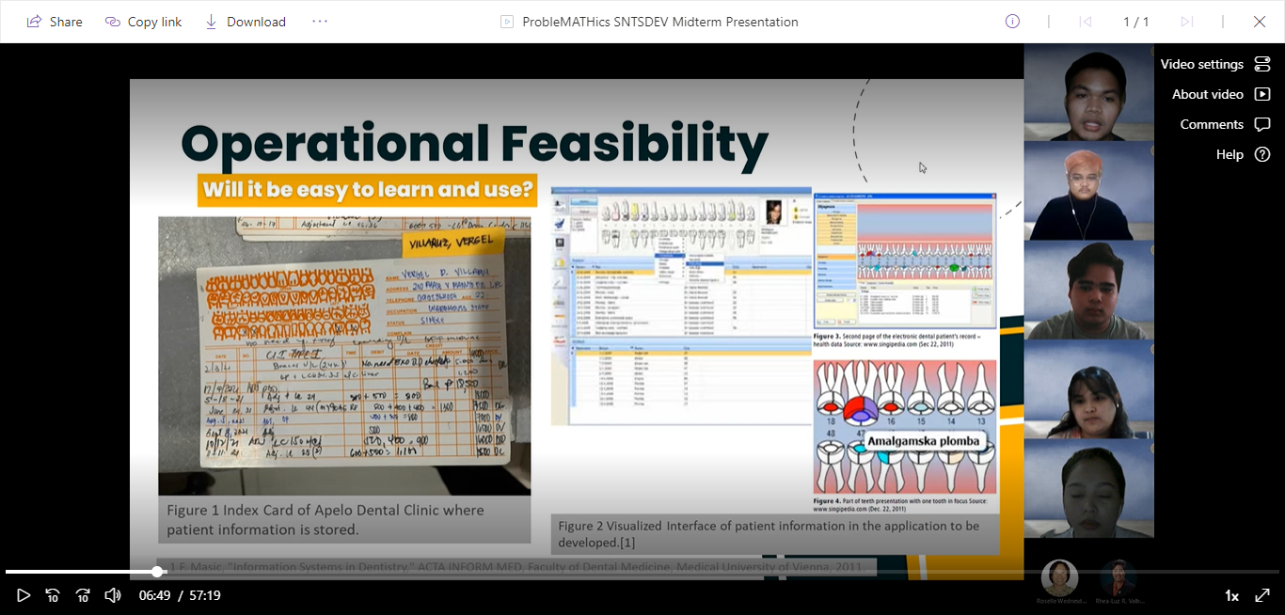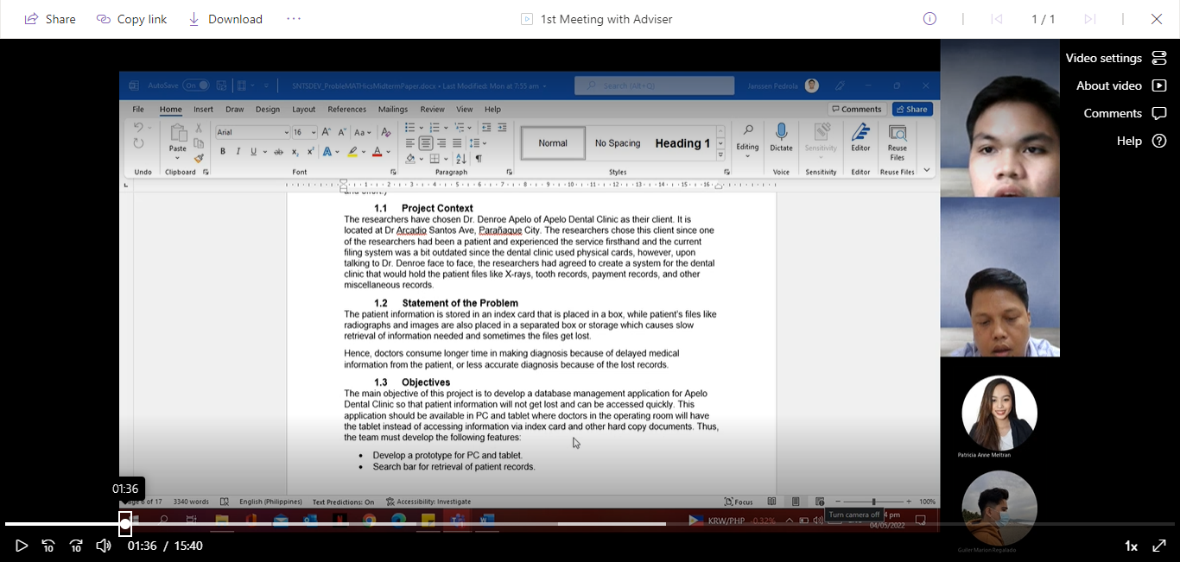

Fig. 43 Midterm Presentation dated May 4.2022

Fig. 44 First adviser meeting dated May 5, 2022

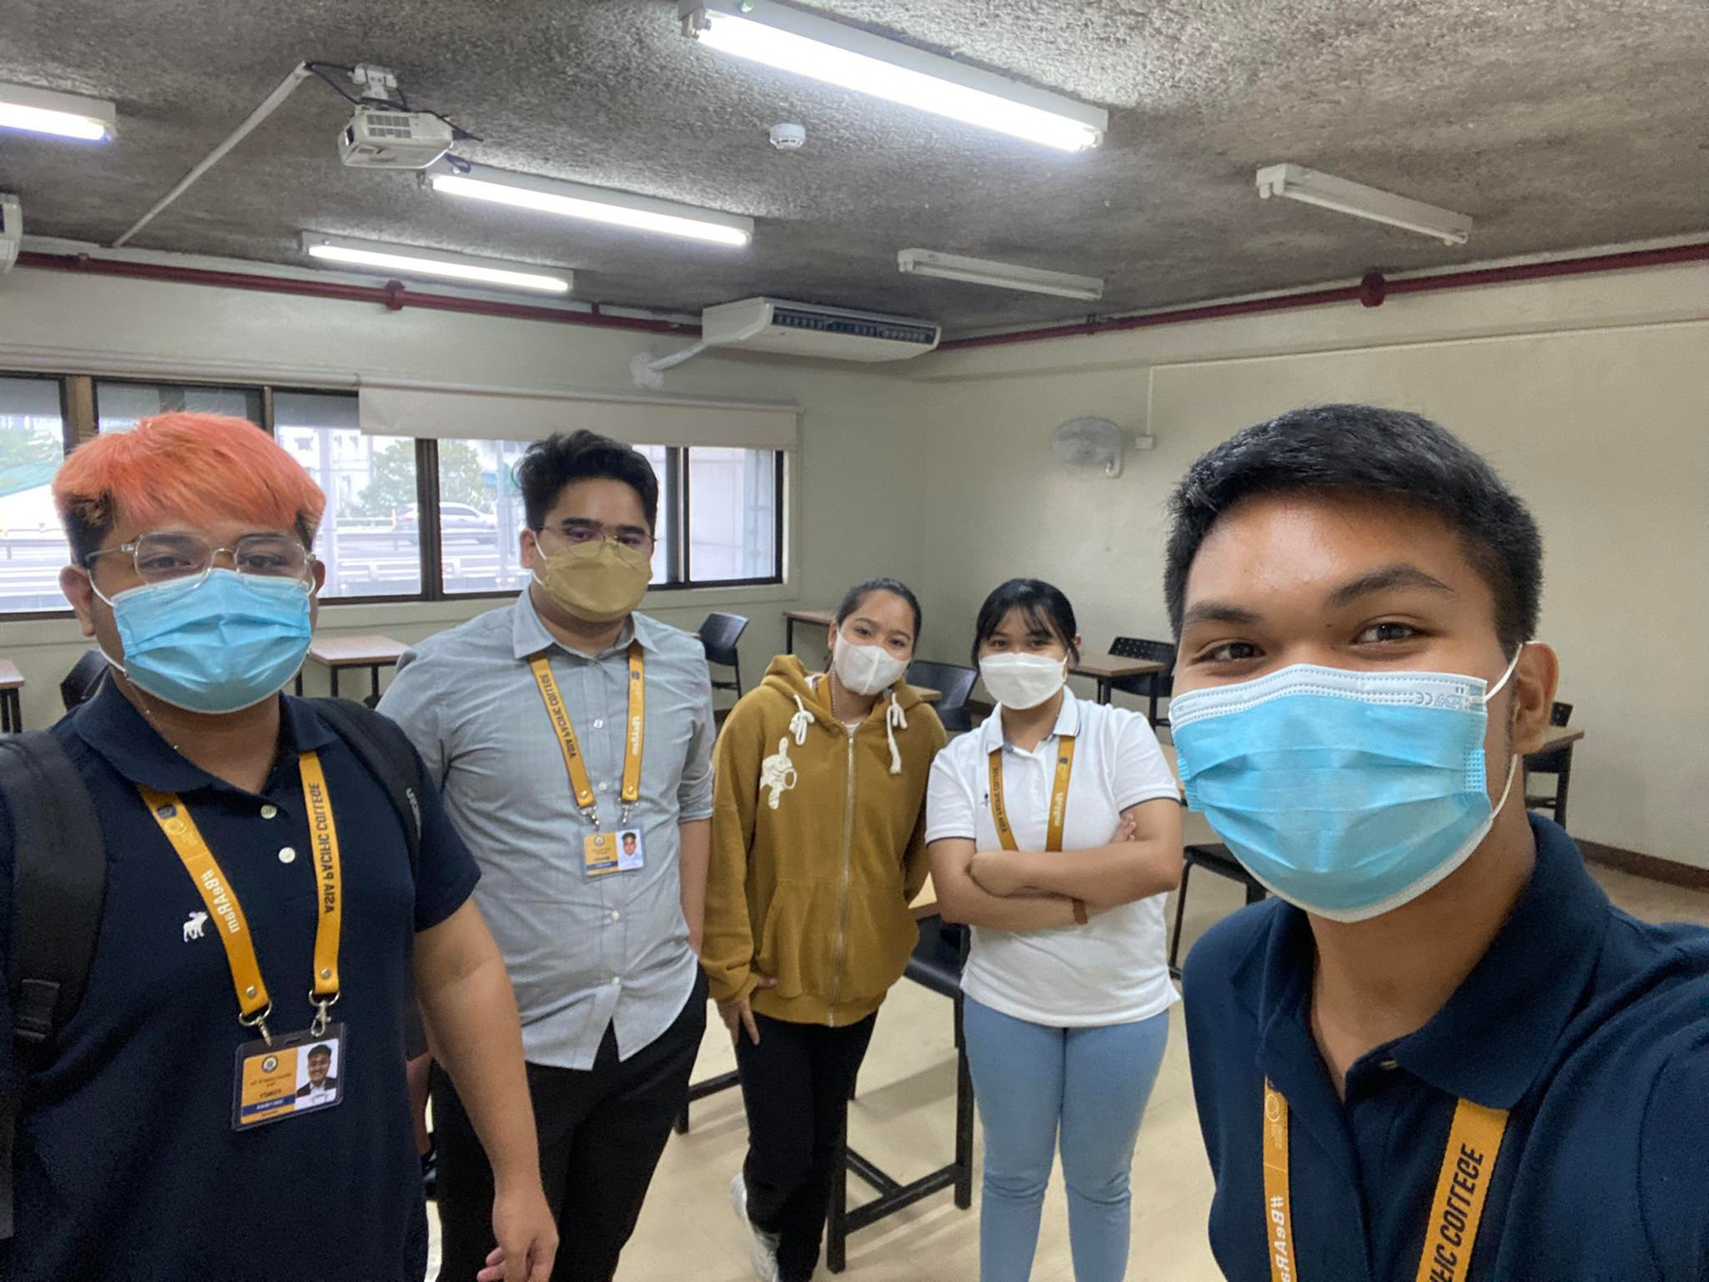

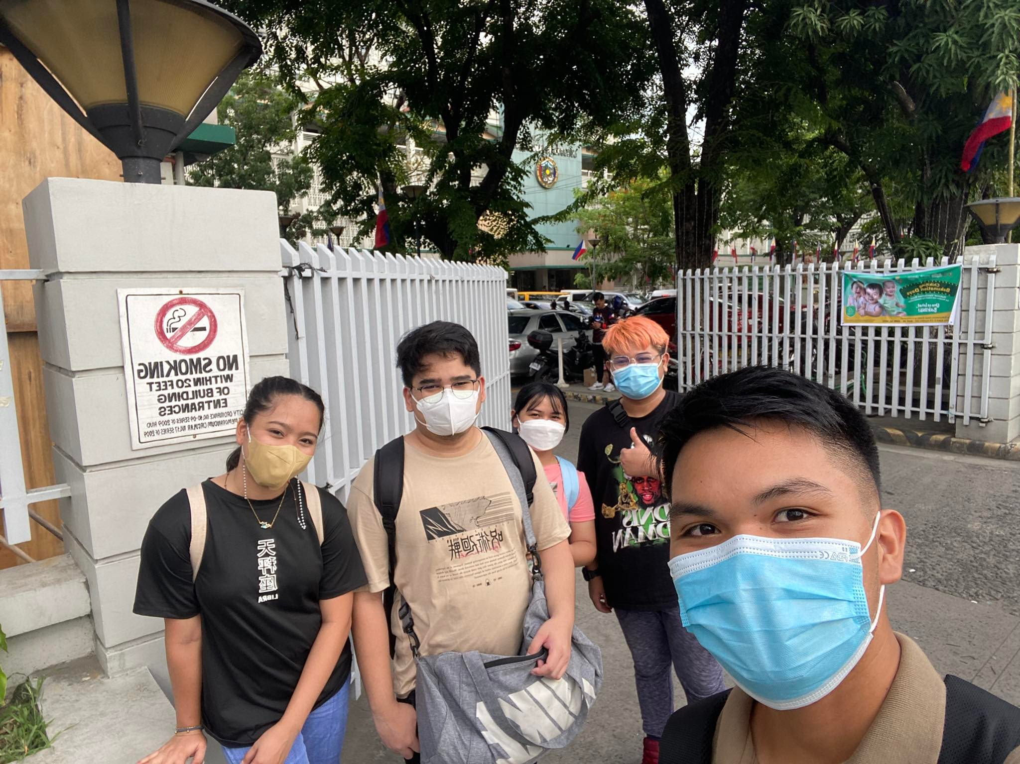

Fig. 45 User interview at Apelo Dental Clinic dated May 27, 2022

Fig. 46 Face-to-face group meeting at APC dated May 23,2022

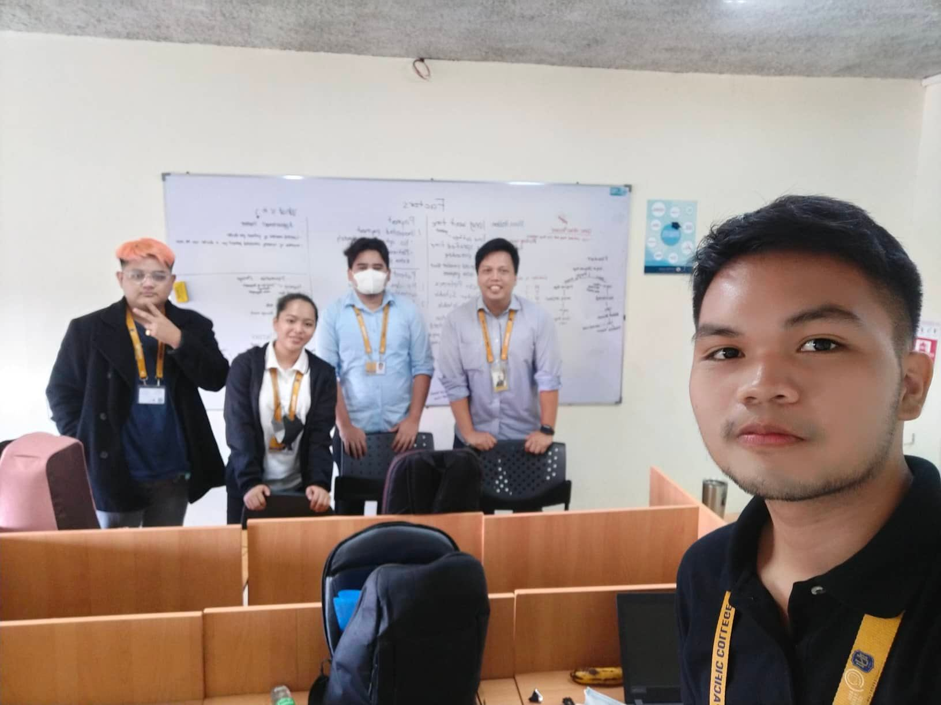

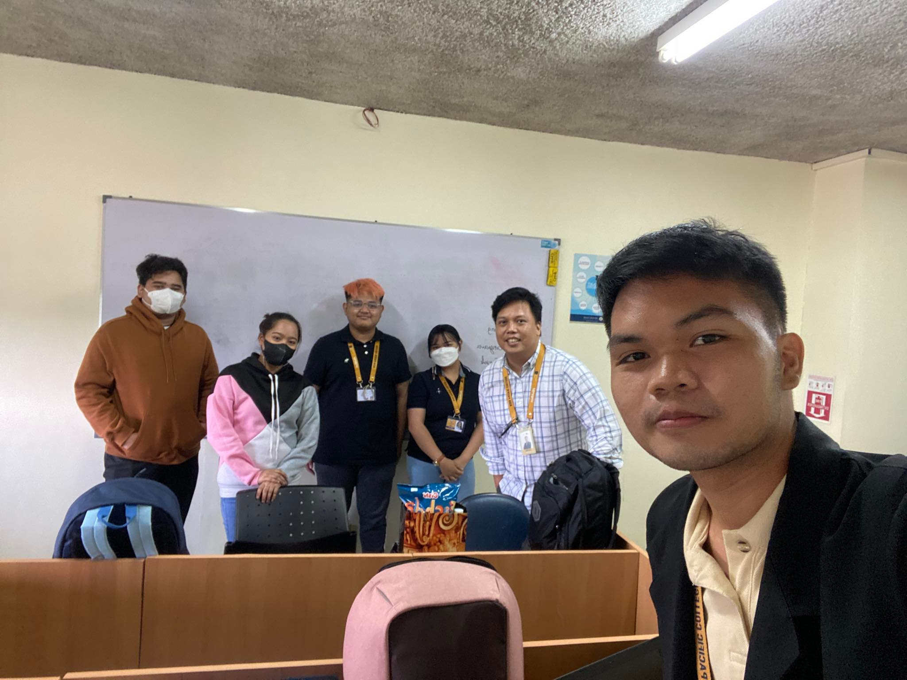

Fig. 47 Group Meeting at APC and adviser consultation dated May 31, 2022

Fig. 48 Group Meeting at APC with adviser consultation dated June 2, 2022

## Appendix C: Other Reference Pictures

This appendix contains other images that is relevant to the paper that can be used as reference in some of the content in the paper.

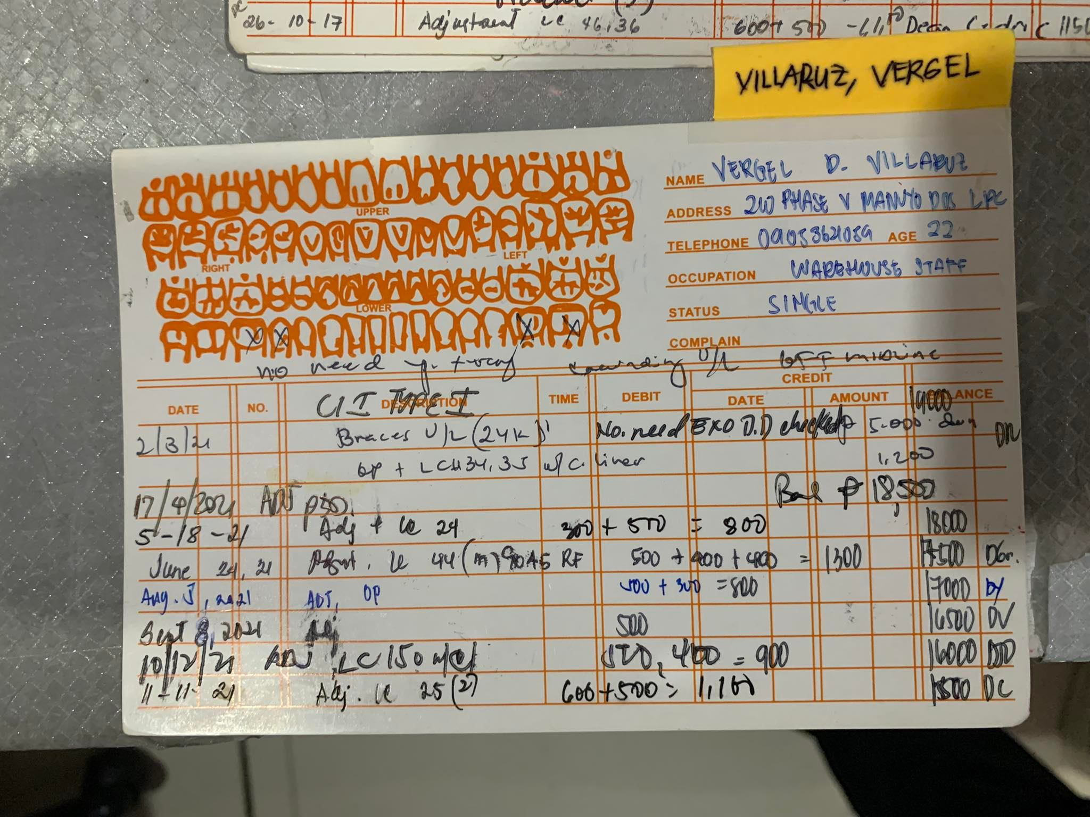

Fig. 49 ADC index card of a patient

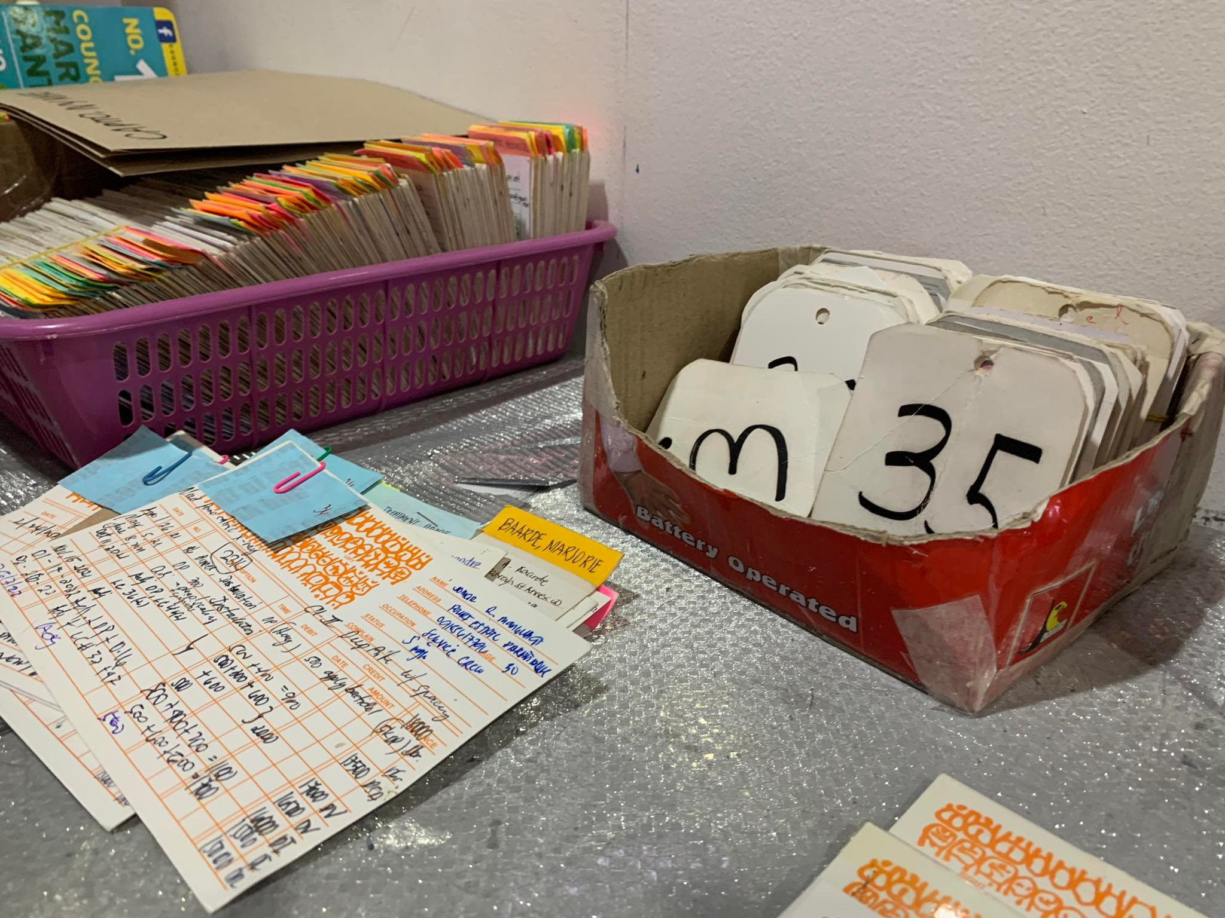

Fig. 50 ADC numbered card and index card clipped with the piece of paper where doctor writes the payment details.

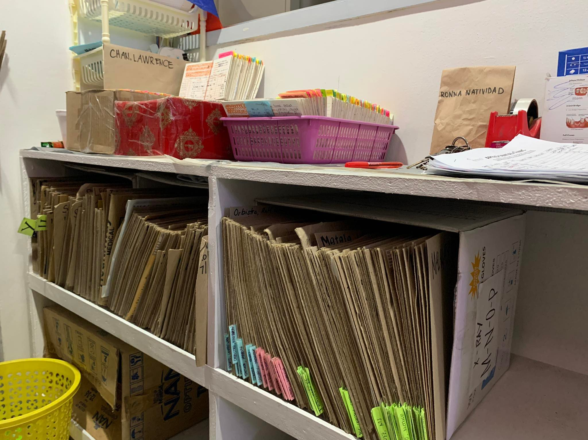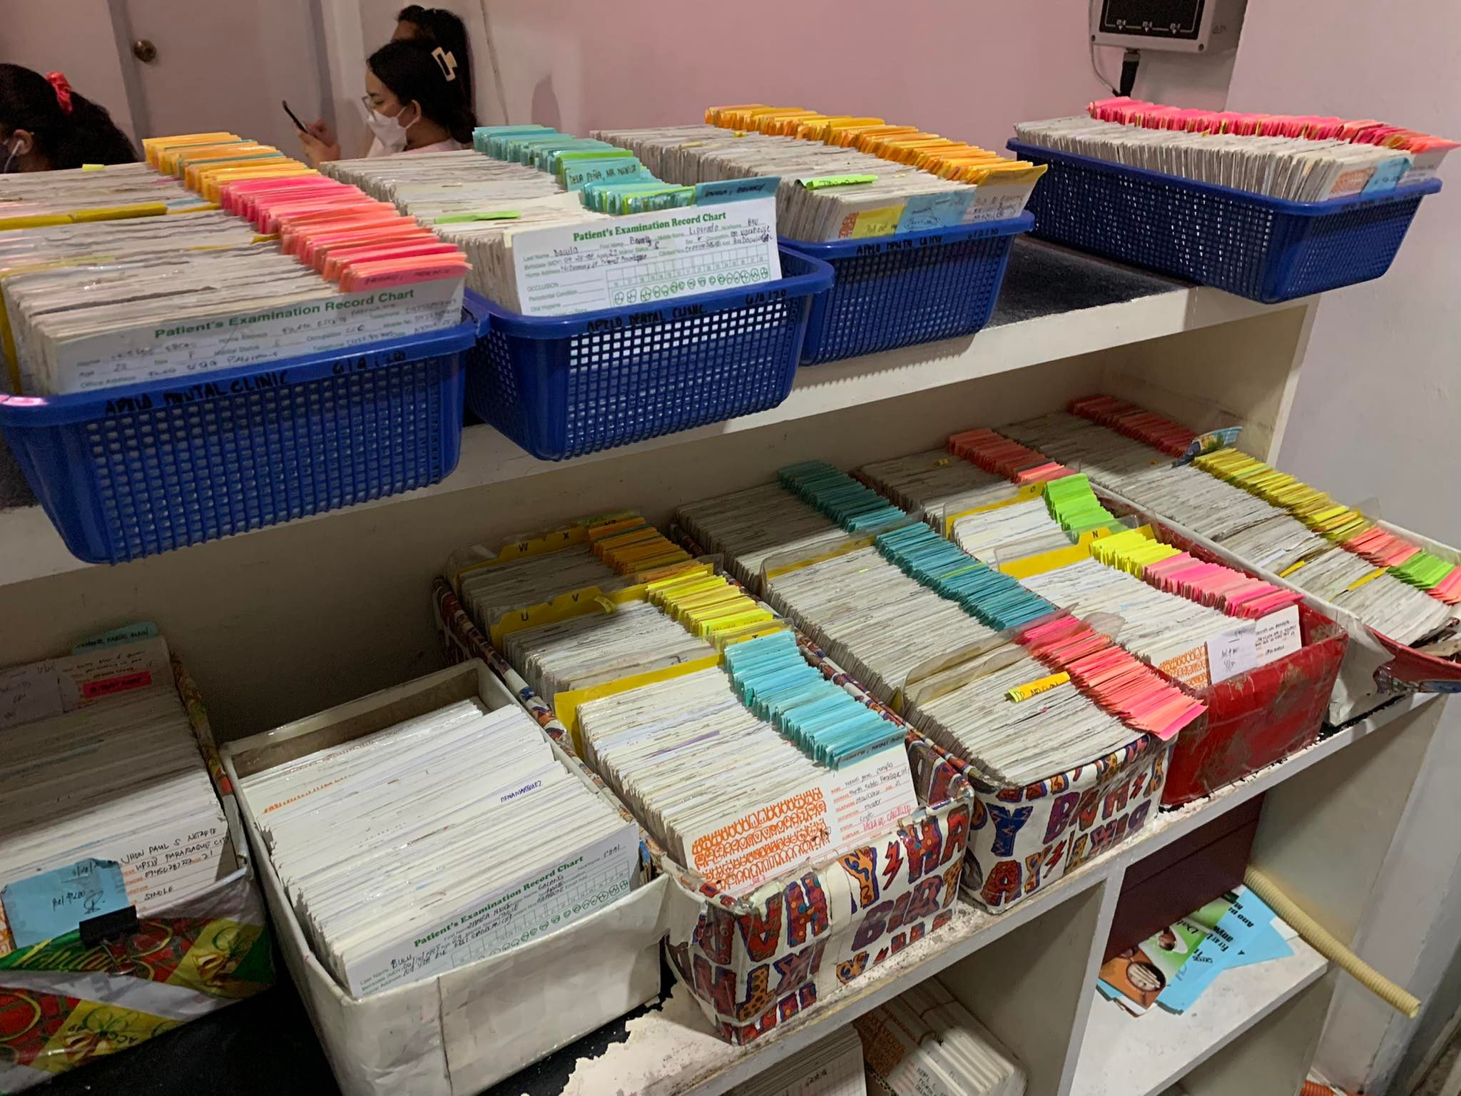

Fig. 51 ADC's Xray Files

Fig. 52 ADC's index cards filed in a tray

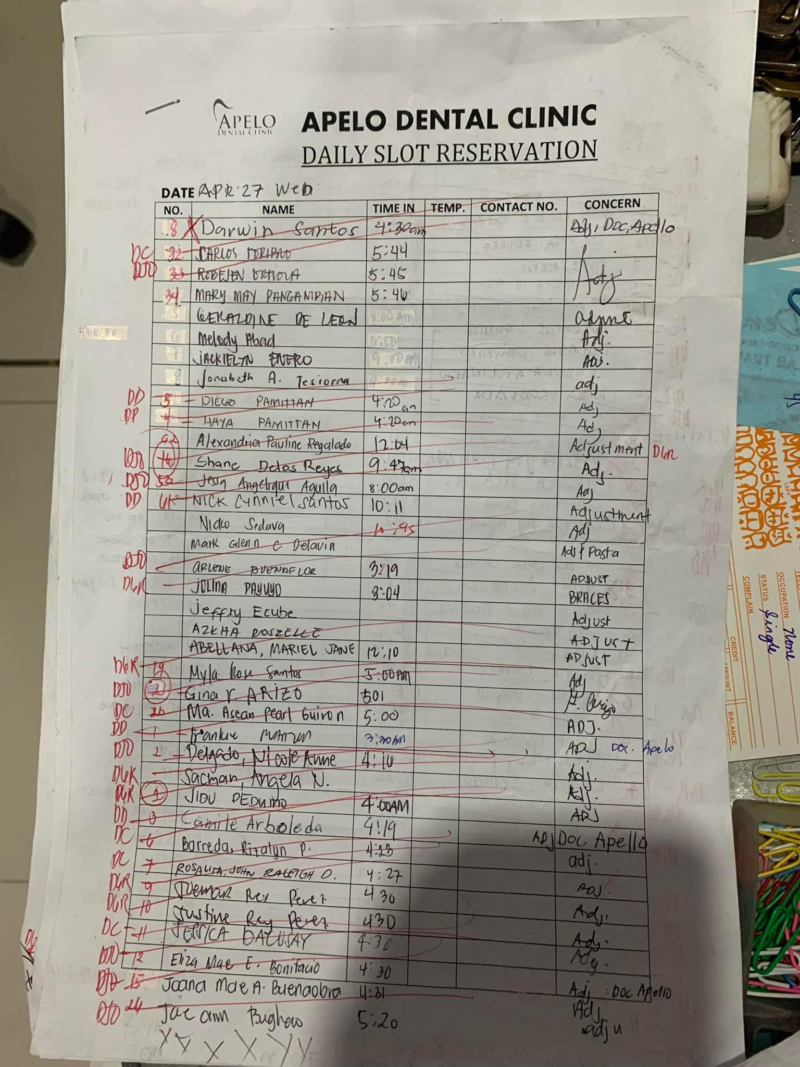

Fig. 53 ADC's log sheet that is filled by the patients starting from 5 am

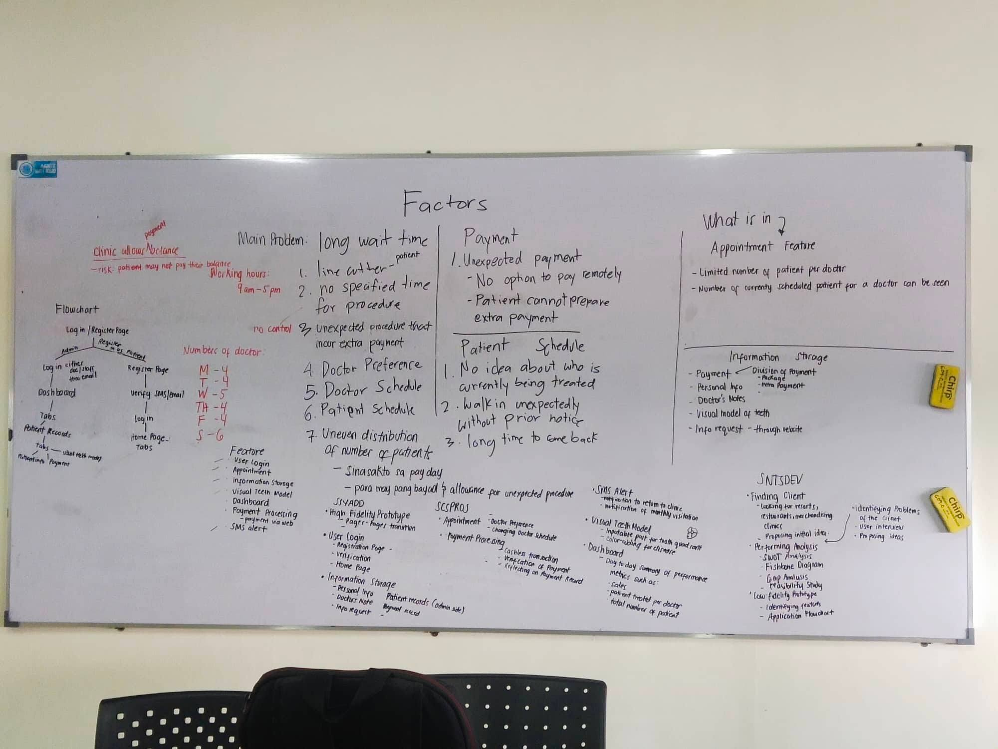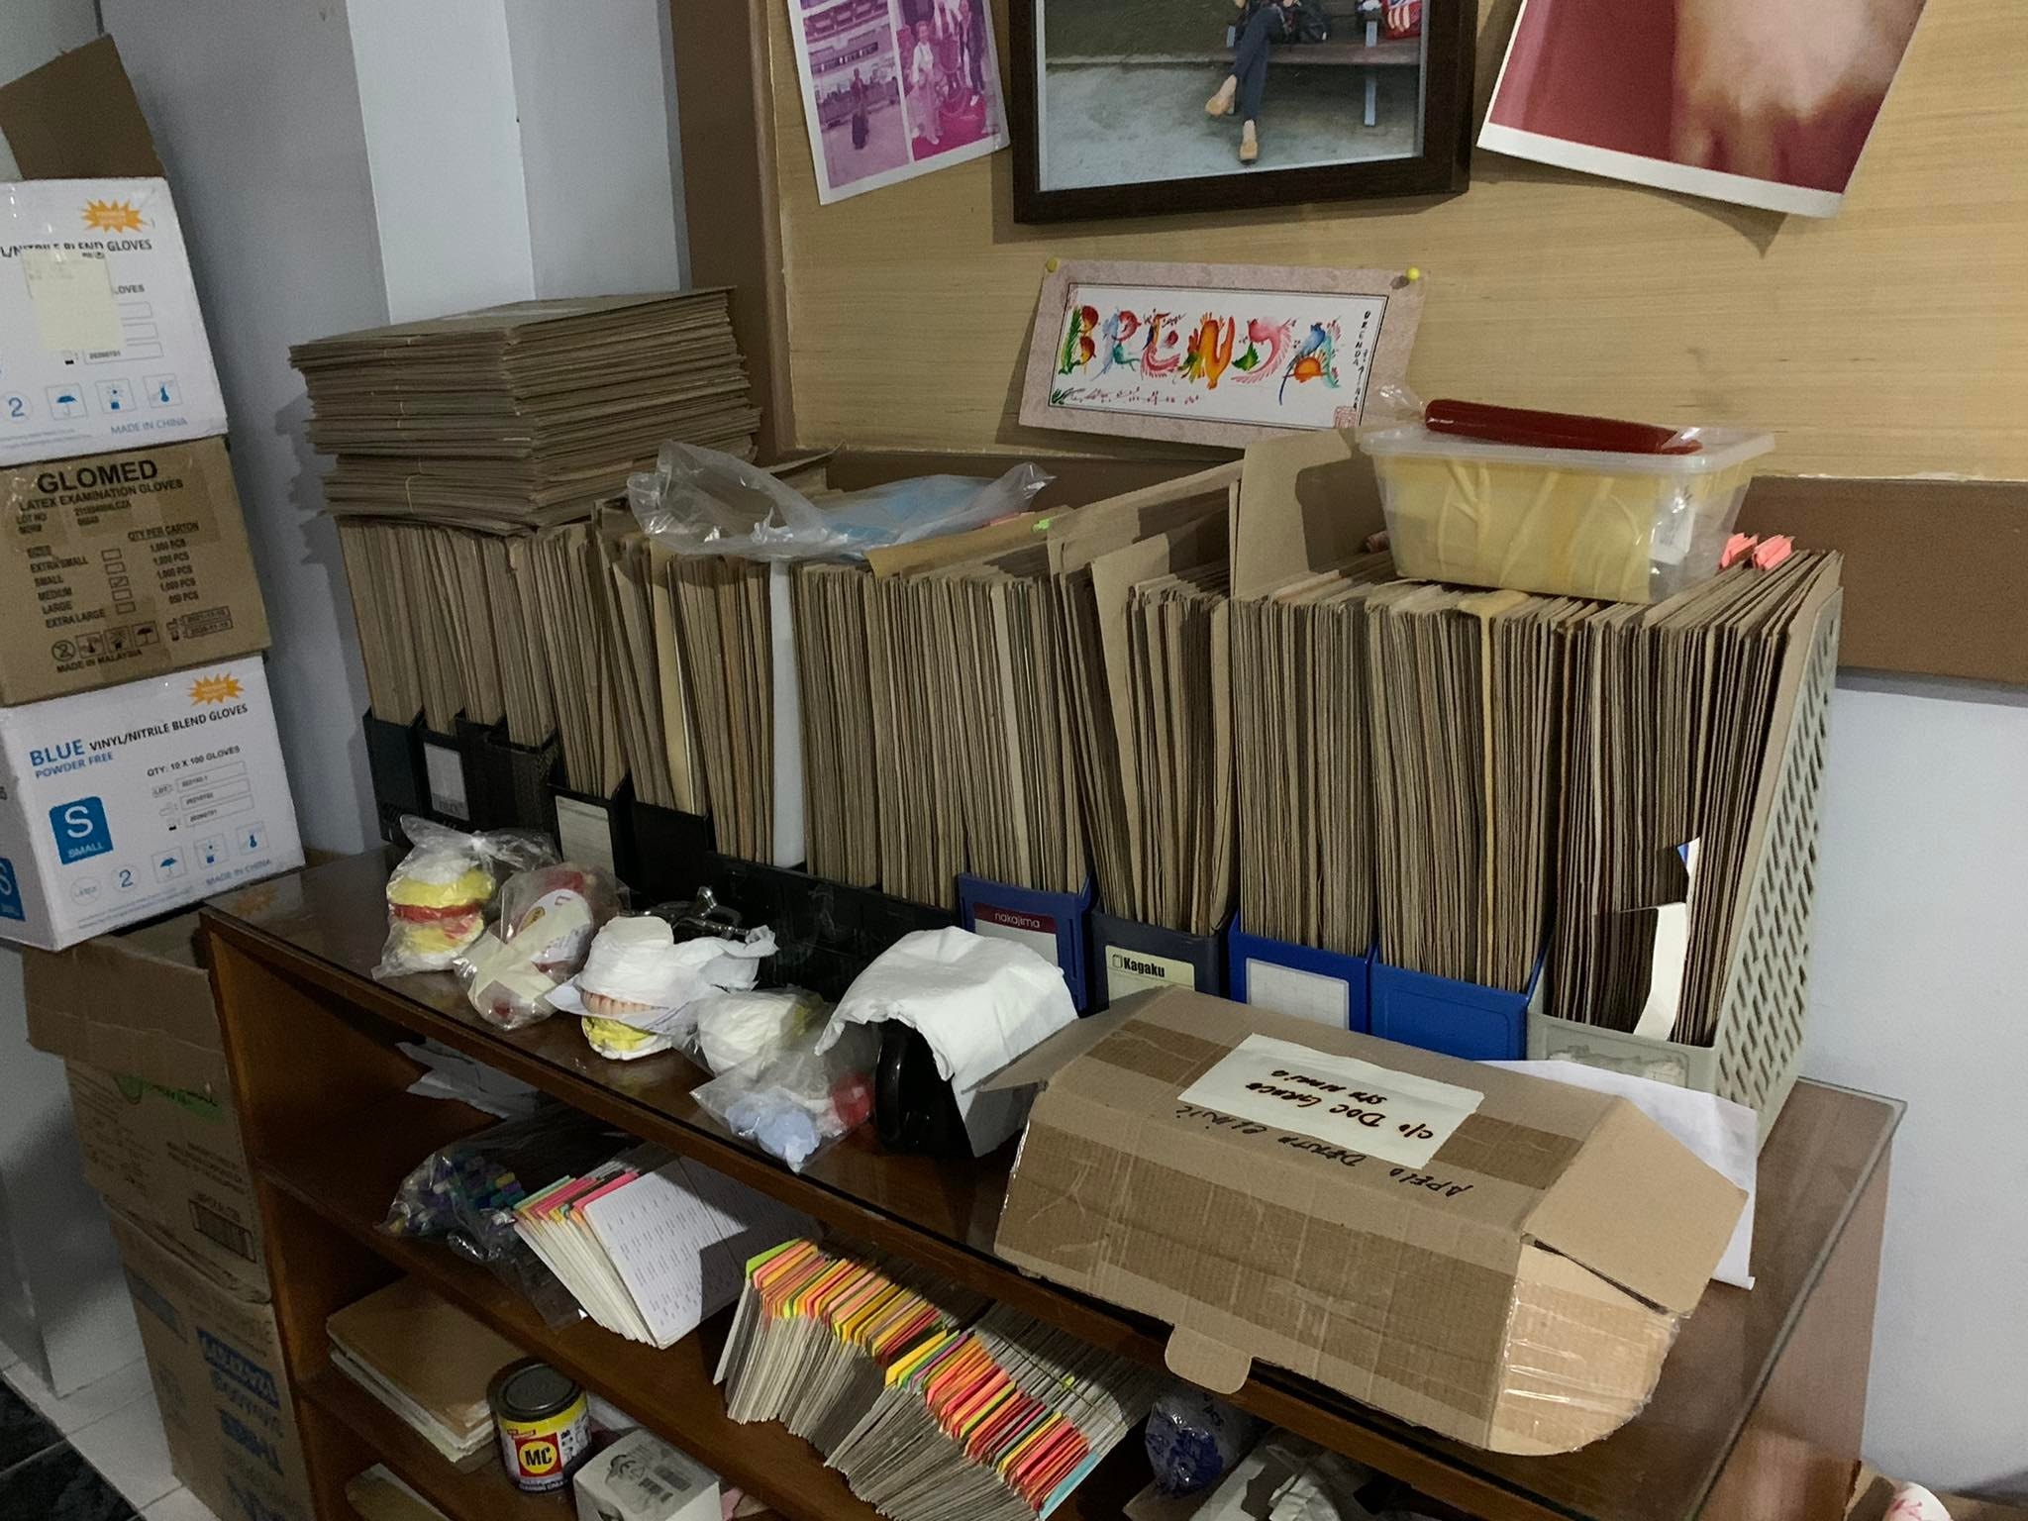

Fig. 54 Discussion during the group's meeting at APC dated May 31

Fig. 55 ADC’s other filed files

## Appendix D: Methodology

This chapter explains the methodology used to collect and analyze data that is important to the research. The process will include data gathering and planning for the application's development. Appendix B contains the minutes of the meeting with the client and adviser.

**Data Gathering**

The researchers have set aside time and effort to schedule a face-to-face meeting with Apelo Dental Clinic to discuss the project idea. Following the discussion, the researchers and clients agree to create a database application to store patient information and payments. The researchers then examine Apelo Dental Clinic's present data storage to familiarize themselves with their database.

**Plan for Application Development**

The researchers will create the application using the Python programming language. The researchers will use My SQL in phpMyAdmin for the application's database because the capacity of this database is sufficient for the data of Apelo dental clinic's patients. Since the client requested a tablet-based application, the researchers will also do data synchronization from the PC to the tablet through Wi-Fi.